# Supplementary Materials

## A.1. Loadings for Values and Concerns Facets

For both honor values and concerns, we used participants’ scores for the respective sub-dimensions within the items to conduct our fit analyses. In doing so, we built upon a series of exploratory and confirmatory factor models, that were conducted in preparation for a separate study (Kirchner-Häusler et al., in preparation). These analyses were conducted with the goal to determine the best fitting factor structure for honor values and concerns at both the individual and group level of analysis, as well as to map cultural variation in the endorsement of the resulting factors. In the subsequent section, we will in short describe the parts of these analyses that are of relevance to the current analyses (for more information on these analyses, please contact the authors directly).

We conducted our model selection in several sequential steps, and separately for both values and concerns (and separately for self-reported and society-reported items within each item group). Our general approach was to first conduct an exploratory factor analysis (EFA) on the items to determine the most meaningful structure at the individual level of analysis. We then conducted a confirmatory factor analysis (CFA) with the found structure to model the individual-level EFA structure identified in the first step, also including an additional “method factor” to account for participants’ acquiescent response tendencies (see Welkenhuysen-Gybels, Billiet, & Cambre, 2003). Next, we tested the identified CFA structure for invariance using multigroup analysis and screened for any necessary adjustments to the factor structure as well as items that differed in their loadings or meaning between comparison groups. The loadings presented below represent the loadings at the individual level of analysis for the final multi-level models of each item group. All analyses were carried out using MPLUS Version 8.5 (Muthén & Muthén, 1998-2011).

## A.1.1. Honor Values

For honor values, both own-endorsement items as well as perceived-societal-endorsement items showed the same factor structure in the final model, with one factor reflecting the maintenance and defense of one’s family reputation (“Family Reputation”), and one factor reflecting the projecting of oneself as strong & powerful and responding decisively to threats to one’s honor (“Strong Self-Image”). During model selection, we excluded two items (*“People must always be ready to defend their honor.”* of the family reputation factor, and *“It is important to promote oneself to others.”* of the strong self-image factor) as these showed signs of non-invariance across our sample of countries. The final model fit the data very well (Own-Endorsement: *CFI* = 0.930, *TLI* = 0.919, *RMSEA* = 0.032; Society-Endorsement: *CFI* = 0.948, *TLI* = 0.939, *RMSEA* = 0.033). Both factors showed adequate reliabilities for both own endorsement (*α*FamilyReputation = 0.85, *α*StrongSelfImage = 0.65) as well as perceived-societal items (*α*FamilyReputation = 0.84, *α*StrongSelfImage = 0.78).

Table 4: Loading Structure for Honor Value Items

|  |  | **Own Endorsement** | | **Perceived-Societal Endorsement** | |
| --- | --- | --- | --- | --- | --- |
| **No** | **Item** | **Family Reputation** | **Strong Self-Image** | **Family Reputation** | **Strong Self-Image** |
| 1 | People should be concerned about their family having a bad reputation. | 0.746 |  | 0.633 |  |
| 2 | People should not allow others to insult their family. | 0.476 |  | 0.419 |  |
| 3 | People should be concerned about defending their families’ reputation. | 0.770 |  | 0.634 |  |
| 4 | People should be concerned about damaging their families’ reputation. | 0.758 |  | 0.596 |  |
| 5 | People always need to show off their power in front of their competitors. |  | 0.449 |  | 0.570 |
| 6 | Men need to protect their women’s reputation at all costs. | 0.491 |  | 0.352 |  |
| 7 | You must punish people who insult you. |  | 0.628 |  | 0.561 |
| 8 | If a person gets insulted and they don’t respond, he or she will look weak. |  | 0.554 |  | 0.668 |

## A.1.2. Honor Concerns

For honor concerns, again both own-endorsement items as well as perceived-societal-endorsement items showed the same four-factor structure in the final model: one factor reflecting “Family Reputation”, one factor reflecting “Sexual Propriety”, one factor reflecting “Family Authority”, one factor reflecting “Integrity”, mirroring the original four honor factor structure of the scale (originally named family honor, feminine honor, masculine honor, integrity honor; Guerra et al., 2013). During model selection, we excluded two items (*“…you were known as someone who cannot support a family?”* and *“…you had the reputation of being someone without sexual experience?”*) from the original masculine honor scale, as these items did not show the highest primary loading on their expected factor. The final model fit the data very well (Own-Endorsement: *SRMR*Within = 0.040; Society-Endorsement: *SRMR*Within = 0.042). Both factors showed adequate reliabilities for both own-endorsement (*α*FamilyReputation = 0.76, *α*SexualPropriety = 0.85; *α*FamilyAuthority = 0.85, *α*Integrity = 0.76) as well as perceived-societal items (*α*FamilyReputation = 0.80, *α*SexualPropriety = 0.87; *α*FamilyAuthority = 0.85, *α*Integrity = 0.88).

Table 5: Loading Structure for Honor Concern Items

|  |  | **Own Endorsement** | | | | **Perceived-Societal Endorsement** | | | |
| --- | --- | --- | --- | --- | --- | --- | --- | --- | --- |
| **No** | **Item** | **Family Reputation** | **Sexual Propriety** | **Family Authority** | **Integrity** | **Family Reputation** | **Sexual Propriety** | **Family Authority** | **Integrity** |
| 1 | ...your family had a bad reputation? | 0.530 |  |  |  | 0.313 |  |  |  |
| 2 | ...you did something to damage your family’s reputation? | 0.339 |  |  |  | 0.063 |  |  |  |
| 3 | ...you let other people insult your family? | 0.278 |  |  |  | 0.120 |  |  |  |
| 4 | ...your sister or mother had the reputation of sleeping around? | 0.687 |  |  |  | 0.431 |  |  |  |
| 5 | ...you were known as someone who has had many different sexual partners? |  | 0.787 |  |  |  | 0.685 |  |  |
| 6 | ...you changed boyfriend/girlfriend often? |  | 0.516 |  |  |  | 0.495 |  |  |
| 7 | ...you were known as someone whom it is easy to sleep with? |  | 0.685 |  |  |  | 0.567 |  |  |
| 8 | ...you slept with someone without starting a serious relationship with that person? |  | 0.633 |  |  |  | 0.600 |  |  |
| 9 | ...you lacked authority over your own family? |  |  | 0.781 |  |  |  | 0.685 |  |
| 10 | ...you were known as someone who lacks authority over your own family? |  |  | 0.770 |  |  |  | 0.680 |  |
| 11 | ...you had the reputation of being dishonest with others? |  |  |  | 0.284 |  |  |  | 0.383 |
| 12 | ...you lied to others? |  |  |  | 0.535 |  |  |  | 0.628 |
| 13 | ...you were hypocritical? |  |  |  | 0.373 |  |  |  | 0.591 |
| 14 | ...you did not keep your word? |  |  |  | 0.389 |  |  |  | 0.575 |

## A.2. Overview of Response Surface Analysis

We followed recent recommendations (Schönbrodt, 2016; Humberg et al., 2019) for conducting and interpreting our *Response Surface Analyses* (RSA) with honor values and honor concerns. As described in the manuscript, RSA represents an analytical tool to test whether the fit (or “congruence”) between two variables (x and y) is systematically linked to a third, dependent variable (z). We used RSA to examine the congruence between a participant’s own endorsement (x) and their perceived-societal endorsement (y) to predict their subjective well-being (z).

**Analysis Steps.** We conducted our test of congruence effects with RSA in several steps: firstly, we fitted a full polynomial regression model to the data, including the two linear terms of the fit variables (b1 and b2), their interaction (b4), as well as two squared terms for both fit variables (b3 and b5). We then tested the full polynomial model against various simpler, more constrained models, and chose the best fitting and most parsimonious model as our final model for the interpretation of RSA model parameters (for an overview of the different models, please see the supplementary materials). Secondly, we then determined the presence of fit effects by interpreting the final model, in terms of its model parameters b1 to b5, as well as by plotting the model’s three-dimensional *response surface* and interpreting it graphically.

**Response Surface.** The three-dimensional, squared response surface maps pairs of predictor scores (on the x- and y-axes) variables against the predicted scores on the outcome variable (on the z-axis). Given predictors are commensurable (i.e., on the same scale), of particular interest to questions of congruence are three elements of the response surface. Firstly, the *Line of Incongruence* (LOIC; shown in blue in the plots), which is the line for which x equals the opposite of y (i.e., x = -y, or the line leading from the front left corner of the coordinate cube to the back right corner of the coordinate cube), representing different levels of mismatch between the two predictors, and secondly, the *Line of Congruence* (LOC; shown in red in the plots, or the line leading from the bottom corner of the coordinate cube to the top corner of the coordinate cube), which is the line for which x equals y, representing different levels of matching values of x and y. These two lines are generally described by four parameters *a1* to *a4*, which are composites of the model coefficients *b1* to *b5*, and which represent the curvature and slope of the two diagonal lines of the response surface. Hereby, the parameter **a1** describes the slope (upward or downward) of the Line of Congruence at the midpoint 0,0, and **a2** describes the curvature (linear, u-shape, or inverted u-shape) of the Line of Congruence. Analogously, the parameter **a3** describes the slope (upward or downward) of the Line of Incongruence at the midpoint (0,0), and **a4** describes the curvature (linear, u-shape, or inverted u-shape) of the Line of Incongruence. These parameters are calculated as follows (please refer to Schönbrodt, 2016, or Nestler, Humberg, & Schönbrodt, 2016, for more information on the calculations for the *a* parameters):

**a1** = b1 + b2

**a2** = b3 + b4 + b5

**a3** = b1 - b2

**a4** = b3 - b4 + b5

In addition to the LOC and LOIC, the *first principal axis* (FPA) is also usually considered in testing for fit effects. The first principal axis of a “dome-shaped surface is the line with minimal downward curvature, and the first principal axis of a saddle-shape is the line with the maximal upward curvature” (Humberg et al., 2019, p. 417); in other words, the FPA is the “ridge”, or line at the “bend”, of the response surface. The FPA can be described by the parameters *p10* and *p11*, which are also composites of *b1* to *b5*, and which describe the projection of the FPA as a two-dimensional line on the bottom of the response surface cube. More practically, *p10* represents the intercept of the projected FPA and can be regarded as the vertical shift of the FPA from the line of congruence, whereas *p11* represents the slope of the projected FPA, and can be regarded as the rotation of the FPA from the line of congruence. In combination, *p10* and *p11* are often interpreted as indicators of whether the ridge (which represents the line of the response surface of highest, or lowest, outcome scores, if the surface has curvature) is systematically shifted away from the line where congruence is highest (the LOC, where x = y).

**Conditions for a broad fit effect.** The presence of congruence effects is determined by the joint interpretation of these three elements (and their associated statistical parameters). Humberg and colleagues (2019) outline four conditions to conclude a *congruence effect in the broadest way*: Firstly, the FPA must not deviate significantly from the LOC. This is reflected statistically in the two conditions that (1) *p10* must not be significantly different from 0 (indicating no vertical “shift” away of the FPA from the LOC), and (2) that *p11* must not be significantly different from 1 (indicating no rotation of the FPA away from the LOC), respectively. Furthermore, the LOIC must represent an inverted u-shape, with its highest values or peak above the midpoint (0,0). This is reflected statistically in the two conditions that (3) *a4* must be significantly negative (indicating an inverted u-shape of the LOIC, where the highest outcome values are at the top), and (2) that *a3* must not be significantly different from 0 (indicating that the peak of the LOIC over the midpoint 0,0, which is also part of the LOC), respectively. If these four conditions are met, one can conclude that the data support a *congruence effect in a broad sense*, i.e., a pattern in which congruence has a positive effect on the outcome. Graphically, these conditions represent a surface, that shows a down-ward bent shape, and for which the FPA falls on the line of congruence (ensuring that the highest outcome values are found for congruent predictor values). Importantly, a broad congruence effect also allows for main effects of the two predictor variables (e.g., higher values in x or y are by themselves linked to better outcomes); this is unlike a *strict congruence effect*, which does not allow for main effects of the predictors and for which two more conditions (*a2* and *a1* must not be significantly different from 0) must be met (Humberg et al., 2019). In the current analyses, we tested for these four conditions of a *broad congruence effect* in our data, as a statistical representation of our verbal hypotheses. Yet, while we primarily emphasized a congruence pattern for the various facets of honor, we also did neither preclude nor predict the presence of specific additional, level-related effects.

**Model Comparison.** In testing for broad congruence effects in our data, we started by testing a full polynomial model against various simpler, more constrained models, which apply certain constraints to the *b* parameters and which may describe the data equally well, but more parsimoniously (and thus increase power). We then chose the best fitting and most parsimonious model as our final model for the the interpretation of RSA model parameters, and thus the four conditions necessary for a broad congruence effect; certain simpler models may also already fulfill some of these four conditions as a consequence of the introduced model constraints. The simpler models we tested were as follows (Schönbrodt, 2016):

Firstly, a *Rising Ridge* model, which describes a model in which the LOIC shows a negative curvature and the LOC describes a positive linear effect. The introduced constraints are (a) *b1* = *b2*, (b) *b3* = *b5*, and (c) *b4* = -2 * *b5*. In a “Rising Ridge” model, conditions 1,2, and 4 for a broad congruence effect are met as a result of the introduced model constraints, leaving a test of condition 3 (an inverted u-shape of the LOIC) to conclude a broad congruence effect.

Secondly, an *Interaction* Model, which omits the squared terms of the full polynomial model, and as such introduces the constraints that (1) *b3* = 0 and that (2) *b5* = 0. In an “Interaction” model, condition 2 for a broad congruence effect is met as a result of the introduced model constraints, leaving a test of condition 1 (no shift of the FPA), condition 3 (an inverted u-shape of the LOIC), and 4 (slope of the LOIC at 0,0 is 0) to show a broad congruence effect.

Thirdly, a *Squared Difference* model (a “strict congruence model”), which is described solely by an inverted u-shape of the LOIC, and a flat line of the LOC. The introduced constraints are (a) *b1* = 0, (b) *b2* = 0, (c) *b3* = *b5*, and (d) *b4* = -2 * *b5*. In a “Squared Difference” model, conditions 1,2, and 4 for a broad congruence effect are met as a result of the introduced model constraints, leaving a test of condition 3 (an inverted u-shape of the LOIC) to conclude a broad congruence effect.

Fourthly, a *Main Effect* Model, which omits both the squared terms and interaction of the full polynomial model completely. The introduced constraints are (a) *b3* = 0, (b) *b4* = 0, and (d) *b5* = 0. The three-dimensional representation of a main effect model would be a (potentially tilted) flat response surface and so this model does not allow for a congruence effect.

Finally, a *Null Effect* Model, which omits all (linear and squared) terms of the full polynomial model except the intercept, by setting all parameters from *b1* to *b5* to 0. The three-dimensional representation of a main effect model would be a horizontal flat response surface, and as such this model does not allow for a congruence effect.

We chose our final model based on the difference in the *Akaike Information Criterion* (AIC), which can be used to compare both nested and non-nested models and balances model complexity with predictive accuracy (Schönbrodt, 2016). While a lower AIC generally indicates a better fitting model, when comparing models we followed recent recommendations suggesting that a difference in AIC below 2 suggests equal fitting models, a difference in AIC between 2 and 7 suggests some support for the better fitting model, and a difference in AIC above 7 signals that the worse fitting model may be implausible compared to the better fitting model (Symonds & Moussalli, 2011; Burnham et al., 2011).

**Gender Differences.** We tested for potential gender differences by including interactions with an effect-coded gender variable for all predictors in the final model and testing for differences in model fit. We concluded that no gender effects were present if a model including interactions of the predictors with gender fit as well as a model without these interactions included, based on the AIC and Chi-Square difference. We found no indication of gender differences in any of our final models, i.e., adding interactions with gender into any final model did not significantly increase the model fit as measured by the Chi-Square, and the model without gender interactions also showed consistently better fit than the one including interactions based on the AIC (difference in AIC of at least 2).

**Data Preparation and Model Specification.** We ran all models as multilevel structural equation models in the R package *lavaan* (Rosseel, 2012; note that we used an SEM framework with manifest variables for implementing the model constraints, not for modeling latent variables), with participants nested within countries and including random intercepts to account for higher-level variation in SWB. Prior to our analyses, we standardized both predictors around their shared grand-mean and grand-standard-deviation prior to all analyses to facilitate the interpretation of the response surface. In the second step, we country-mean centered our predictor variables and separated the within-country variance from the between-country variance by adding the country means as separate variables into the model (Enders & Tofighi, 2007). We included this step to not confound our fit analyses with differences in overall levels between our larger groups (countries), as we were primarily interested in the individual-level, within-country fit. The included country-level variables were non-significant in all our RSA models.

## A.2.1. Family Reputation Values

For family reputation values, we found that a **Rising Ridge Model** was the best fitting and most parsimonious model according to our criteria based on the AIC (a difference of 4 to the second best fitting, full model).

Table 6: Model Comparison for Family Reputation Values

|  |  |  | ***R2*** | |
| --- | --- | --- | --- | --- |
| **Model** | ***df*** | ***AIC*** | ***Level 1*** | ***Level 2*** |
| Full Model | 10 | 38,544 | 0.043 | 0.150 |
| Interaction Model | 8 | 38,550 | 0.039 | 0.145 |
| ***Rising Ridge Model*** | 7 | 38,540 | 0.042 | 0.148 |
| Main Effects Model | 7 | 38,560 | 0.034 | 0.159 |
| Squared Difference Model | 6 | 38,560 | 0.033 | 0.153 |
| Null Model | 5 | 38,631 | 0.000 | 0.152 |
| Note. Presented are the relevant model fitting indices for the respective models compared to the Response Surface Analyses with family reputation values. The best-fitting model according to the AIC is highlighted in italic and bold. | | | | |

Examining the model coefficients for the Rising Ridge Model, we found support for a broad congruence effect for own and perceived-societal family reputation values and subjective well-being. The constraints introduced in a Rising Ridge model already imply that the FPA does not deviate significantly from the LOC (as *p10* is constrained to 0, and *p11* is constrained to 1), as well as that the slope of the LOIC at the midpoint 0,0 is equal to 0 (as *a3* is constrained to 0), and as such fulfills 3 out of the 4 conditions for a broad congruence effect. The model also met the final condition: an inverted u-shape of the LOIC (as indicated by a significant negative *a4* = -0.35, *p* < .001, 95% CI = [-0.45,-0.24]). The model also showed a positive linear effect of the LOC at the midpoint 0,0 (as indicated by a significant positive *a1* = 0.26, *p* < .001, 95% CI = [0.15,0.37]), suggesting a positive effect between general levels of honor endorsement and subjective well-being. A majority of non-matching cases were located left of the LOC, suggesting that instances of mismatch in which participants rated their society to hold stronger family reputation values than they themselves did were more frequent than vice-versa. The higher country-level variables for both own value endorsement as well as perceived-societal value endorsement were non-significant, as was the between-country variance in intercepts of subjective well-being.

Table 7: Model Parameters for Family Reputation Values (Rising Ridge Model).

|  |  |  |  |  |  | ***95%-CI*** | |
| --- | --- | --- | --- | --- | --- | --- | --- |
| **Label** | **Variable** | ***Estimate*** | ***SE*** | ***z*** | ***p*** | ***LL*** | ***UL*** |
| **Fixed Effects (Level 1)** | |  |  |  |  |  |  |
| b1 | Own Endorsement | 0.129 | 0.028 | 4.682 | 0.000 | 0.075 | 0.183 |
| b2 | Society Endorsement | 0.129 | 0.028 | 4.682 | 0.000 | 0.075 | 0.183 |
| b3 | Own Endorsement (Squared) | -0.086 | 0.013 | -6.573 | 0.000 | -0.112 | -0.061 |
| b4 | Own x Society Interaction | 0.173 | 0.026 | 6.573 | 0.000 | 0.121 | 0.224 |
| b5 | Society Endorsement (Squared) | -0.086 | 0.013 | -6.573 | 0.000 | -0.112 | -0.061 |
| a1 | Linear Effect LOC | 0.258 | 0.055 | 4.682 | 0.000 | 0.150 | 0.366 |
| a2 | Curvature LOC | 0.000 |  |  |  |  |  |
| a3 | Linear Effect LOIC | 0.000 |  |  |  |  |  |
| a4 | Curvature LOIC | -0.346 | 0.053 | -6.573 | 0.000 | -0.449 | -0.243 |
| p11 | Slope of Projected FPA | 1.000 |  |  |  |  |  |
| p10 | Intercept of Projected FPA | 0.000 |  |  |  |  |  |
| **Fixed Effects (Level 2)** | |  |  |  |  |  |  |
| b0 | Grand-Mean SWB | 6.552 | 0.404 | 16.221 | 0.000 | 5.760 | 7.343 |
|  | Country-Score: Own Endorsement | 0.153 | 0.515 | 0.297 | 0.767 | -0.857 | 1.162 |
|  | Country-Score: Society Endorsement | -0.655 | 0.861 | -0.761 | 0.446 | -2.343 | 1.032 |
| **Error Terms** | |  |  |  |  |  |  |
|  | Intercept Variance (Lvl-2) | 0.102 | 0.058 | 1.764 | 0.078 | -0.011 | 0.216 |
|  | Residual Variance (Lvl-1) | 2.722 | 0.082 | 33.299 | 0.000 | 2.562 | 2.882 |
| Note. Shown are parameter coefficients for the final Rising Ridge Model for Family Reputation Values. In a Rising Ridge Model, the following constraints are applied compared to the full model: (a) b1 and b2 are set equal, (b) b3 and b5 are set equal, and (c) b4 is set to be -2 * b5. This implies that a2, a3, a5, and p10 are constrained to zero, and p11 is constrained to 1. | | | | | | | |

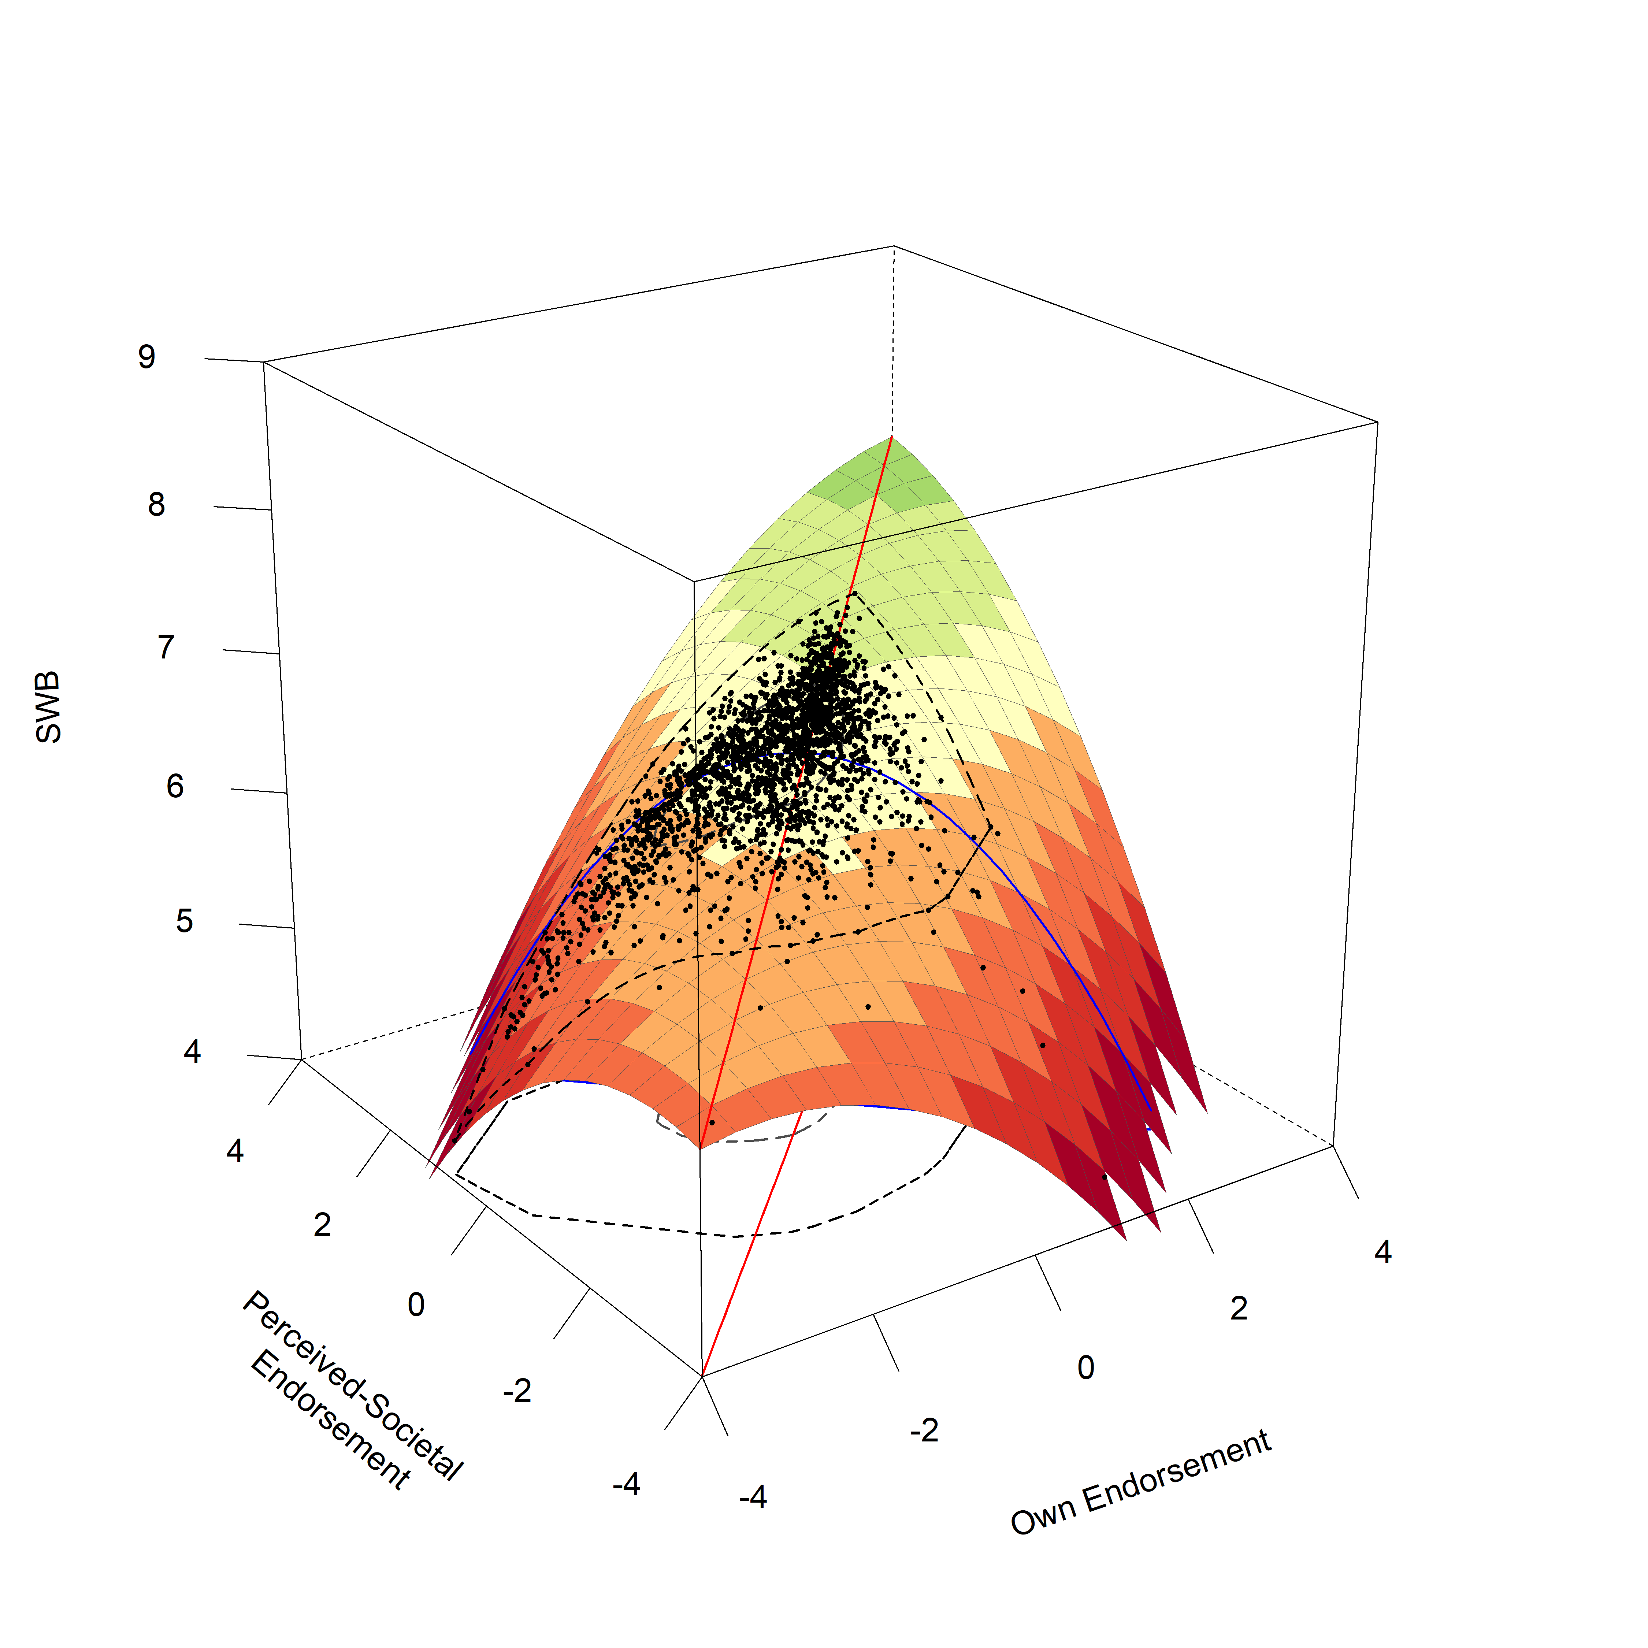

*Figure* *4.*  Shown is the response surface plot for family reputation values. Black points represent the (jittered) data points of participants at their predicted level of SWB. The red line marks the Line of Congruence, the blue line marks the Line of Incongruence. The two inner circles mark a bagplot, which describes the position of the inner 50% of points (the inner circle) and the outer 50% of points (the outer circle), except outliers.

## A.2.2. Strong Self-Image Values

For strong self-image values, we found that an **Interaction Model** was the best fitting and most parsimonious model according to our criteria based on the AIC (a difference of 2 to the second best fitting, full model).

Table 8: Model Comparison for Strong Self-Image Values

|  |  |  | ***R2*** | |
| --- | --- | --- | --- | --- |
| **Model** | ***df*** | ***AIC*** | ***Level 1*** | ***Level 2*** |
| Full Model | 10 | 34,690 | 0.009 | 0.178 |
| ***Interaction Model*** | 8 | 34,688 | 0.008 | 0.169 |
| Rising Ridge Model | 7 | 34,691 | 0.006 | 0.167 |
| Main Effects Model | 7 | 34,694 | 0.005 | 0.172 |
| Squared Difference Model | 6 | 34,696 | 0.003 | 0.170 |
| Null Model | 5 | 34,700 | 0.000 | 0.216 |
| Note. Presented are the relevant model fitting indices for the respective models compared for the Response Surface Analyses with strong self-image values. The best fitting model according to the AIC is highlighted in italic and bold. | | | | |

Examining the model coefficients for the Interaction Model, we found suggestive support for a broad congruence effect for own and perceived-societal strong self-image values and subjective well-being. The constraints introduced in an Interaction model already imply that the slope of the projected FPA is not rotated significantly from the LOC (as *p11* is constrained to 1), and thus already fulfills 1 out of the 4 conditions for a broad congruence effect. Testing the remaining conditions, the current model indeed showed an FPA that was not significantly shifted from the LOC (as indicated by *p10* = 0.24, *p* = .7, 95% CI = [-0.99,1.47]). Furthermore, the LOIC showed a suggestive inverted u-shape (as indicated by *a4* = -0.14, *p* = .005, 95% CI = [-0.25,-0.04]) with its peak over the LOC (as indicated by a non-significant *a3* = -0.04, *p* = .724, 95% CI = [-0.23,0.16]). In addition, this congruence effect was combined with both a negative slope of the LOC at the midpoint 0,0 (*a1* = -0.12, *p* = .045, 95% CI = [-0.23,-0.002]) and a positive curvature of the LOC (a u-shape: *a2* = 0.14, *p* = .005, 95% CI = [0.04,0.25], which is constrained to be the opposite of *a4* in an interaction model), also suggesting a relationship between general levels of honor endorsement and well-being. A majority of non-matching cases were located left of the LOC, suggesting that instances of mismatch in which participants rated their society to hold stronger values related to a strong self-image than they themselves did were more frequent than vice-versa. Again, the higher country-level variables for both own honor endorsement as well as perceived-societal honor endorsement were not significant, as was the between country variance in intercepts of subjective well-being.

Table 9: Model Parameters for Strong Self-Image Values (Interaction Model)

|  |  |  |  |  |  | ***95%-CI*** | |
| --- | --- | --- | --- | --- | --- | --- | --- |
| **Label** | **Variable** | ***Estimate*** | ***SE*** | ***z*** | ***p*** | ***LL*** | ***UL*** |
| **Fixed Effects (Level 1)** | |  |  |  |  |  |  |
| b1 | Own Endorsement | -0.075 | 0.056 | -1.359 | 0.174 | -0.184 | 0.033 |
| b2 | Society Endorsement | -0.040 | 0.060 | -0.677 | 0.498 | -0.157 | 0.076 |
| b3 | Own Endorsement (Squared) | 0.000 |  |  |  |  |  |
| b4 | Own x Society Interaction | 0.145 | 0.052 | 2.801 | 0.005 | 0.044 | 0.247 |
| b5 | Society Endorsement (Squared) | 0.000 |  |  |  |  |  |
| a1 | Linear Effect LOC | -0.116 | 0.058 | -2.001 | 0.045 | -0.229 | -0.002 |
| a2 | Curvature LOC | 0.145 | 0.052 | 2.801 | 0.005 | 0.044 | 0.247 |
| a3 | Linear Effect LOIC | -0.035 | 0.100 | -0.353 | 0.724 | -0.230 | 0.160 |
| a4 | Curvature LOIC | -0.145 | 0.052 | -2.801 | 0.005 | -0.247 | -0.044 |
| p11 | Slope of Projected FPA | 1.000 |  |  |  |  |  |
| p10 | Intercept of Projected FPA | 0.242 | 0.628 | 0.386 | 0.700 | -0.988 | 1.472 |
| **Fixed Effects (Level 2)** | |  |  |  |  |  |  |
| b0 | Grand-Mean SWB | 6.730 | 0.482 | 13.971 | 0.000 | 5.786 | 7.674 |
|  | Country-Score: Own Endorsement | 0.477 | 0.430 | 1.108 | 0.268 | -0.367 | 1.320 |
|  | Country-Score: Society Endorsement | -0.626 | 0.574 | -1.089 | 0.276 | -1.751 | 0.500 |
| **Error Terms** | |  |  |  |  |  |  |
|  | Intercept Variance (Lvl-2) | 0.093 | 0.053 | 1.752 | 0.080 | -0.011 | 0.196 |
|  | Residual Variance (Lvl-1) | 2.822 | 0.085 | 33.299 | 0.000 | 2.656 | 2.988 |
| Note. Shown are parameter coefficients for the final Interaction Model for Strong Self-Image Values. In this Interaction Model, the following constraints are applied compared to the full model: b3 and b5 are set to 0. This implies that p11 is constrained to 1, and that a2 and a4 show the same estimate with opposite signs. | | | | | | | |

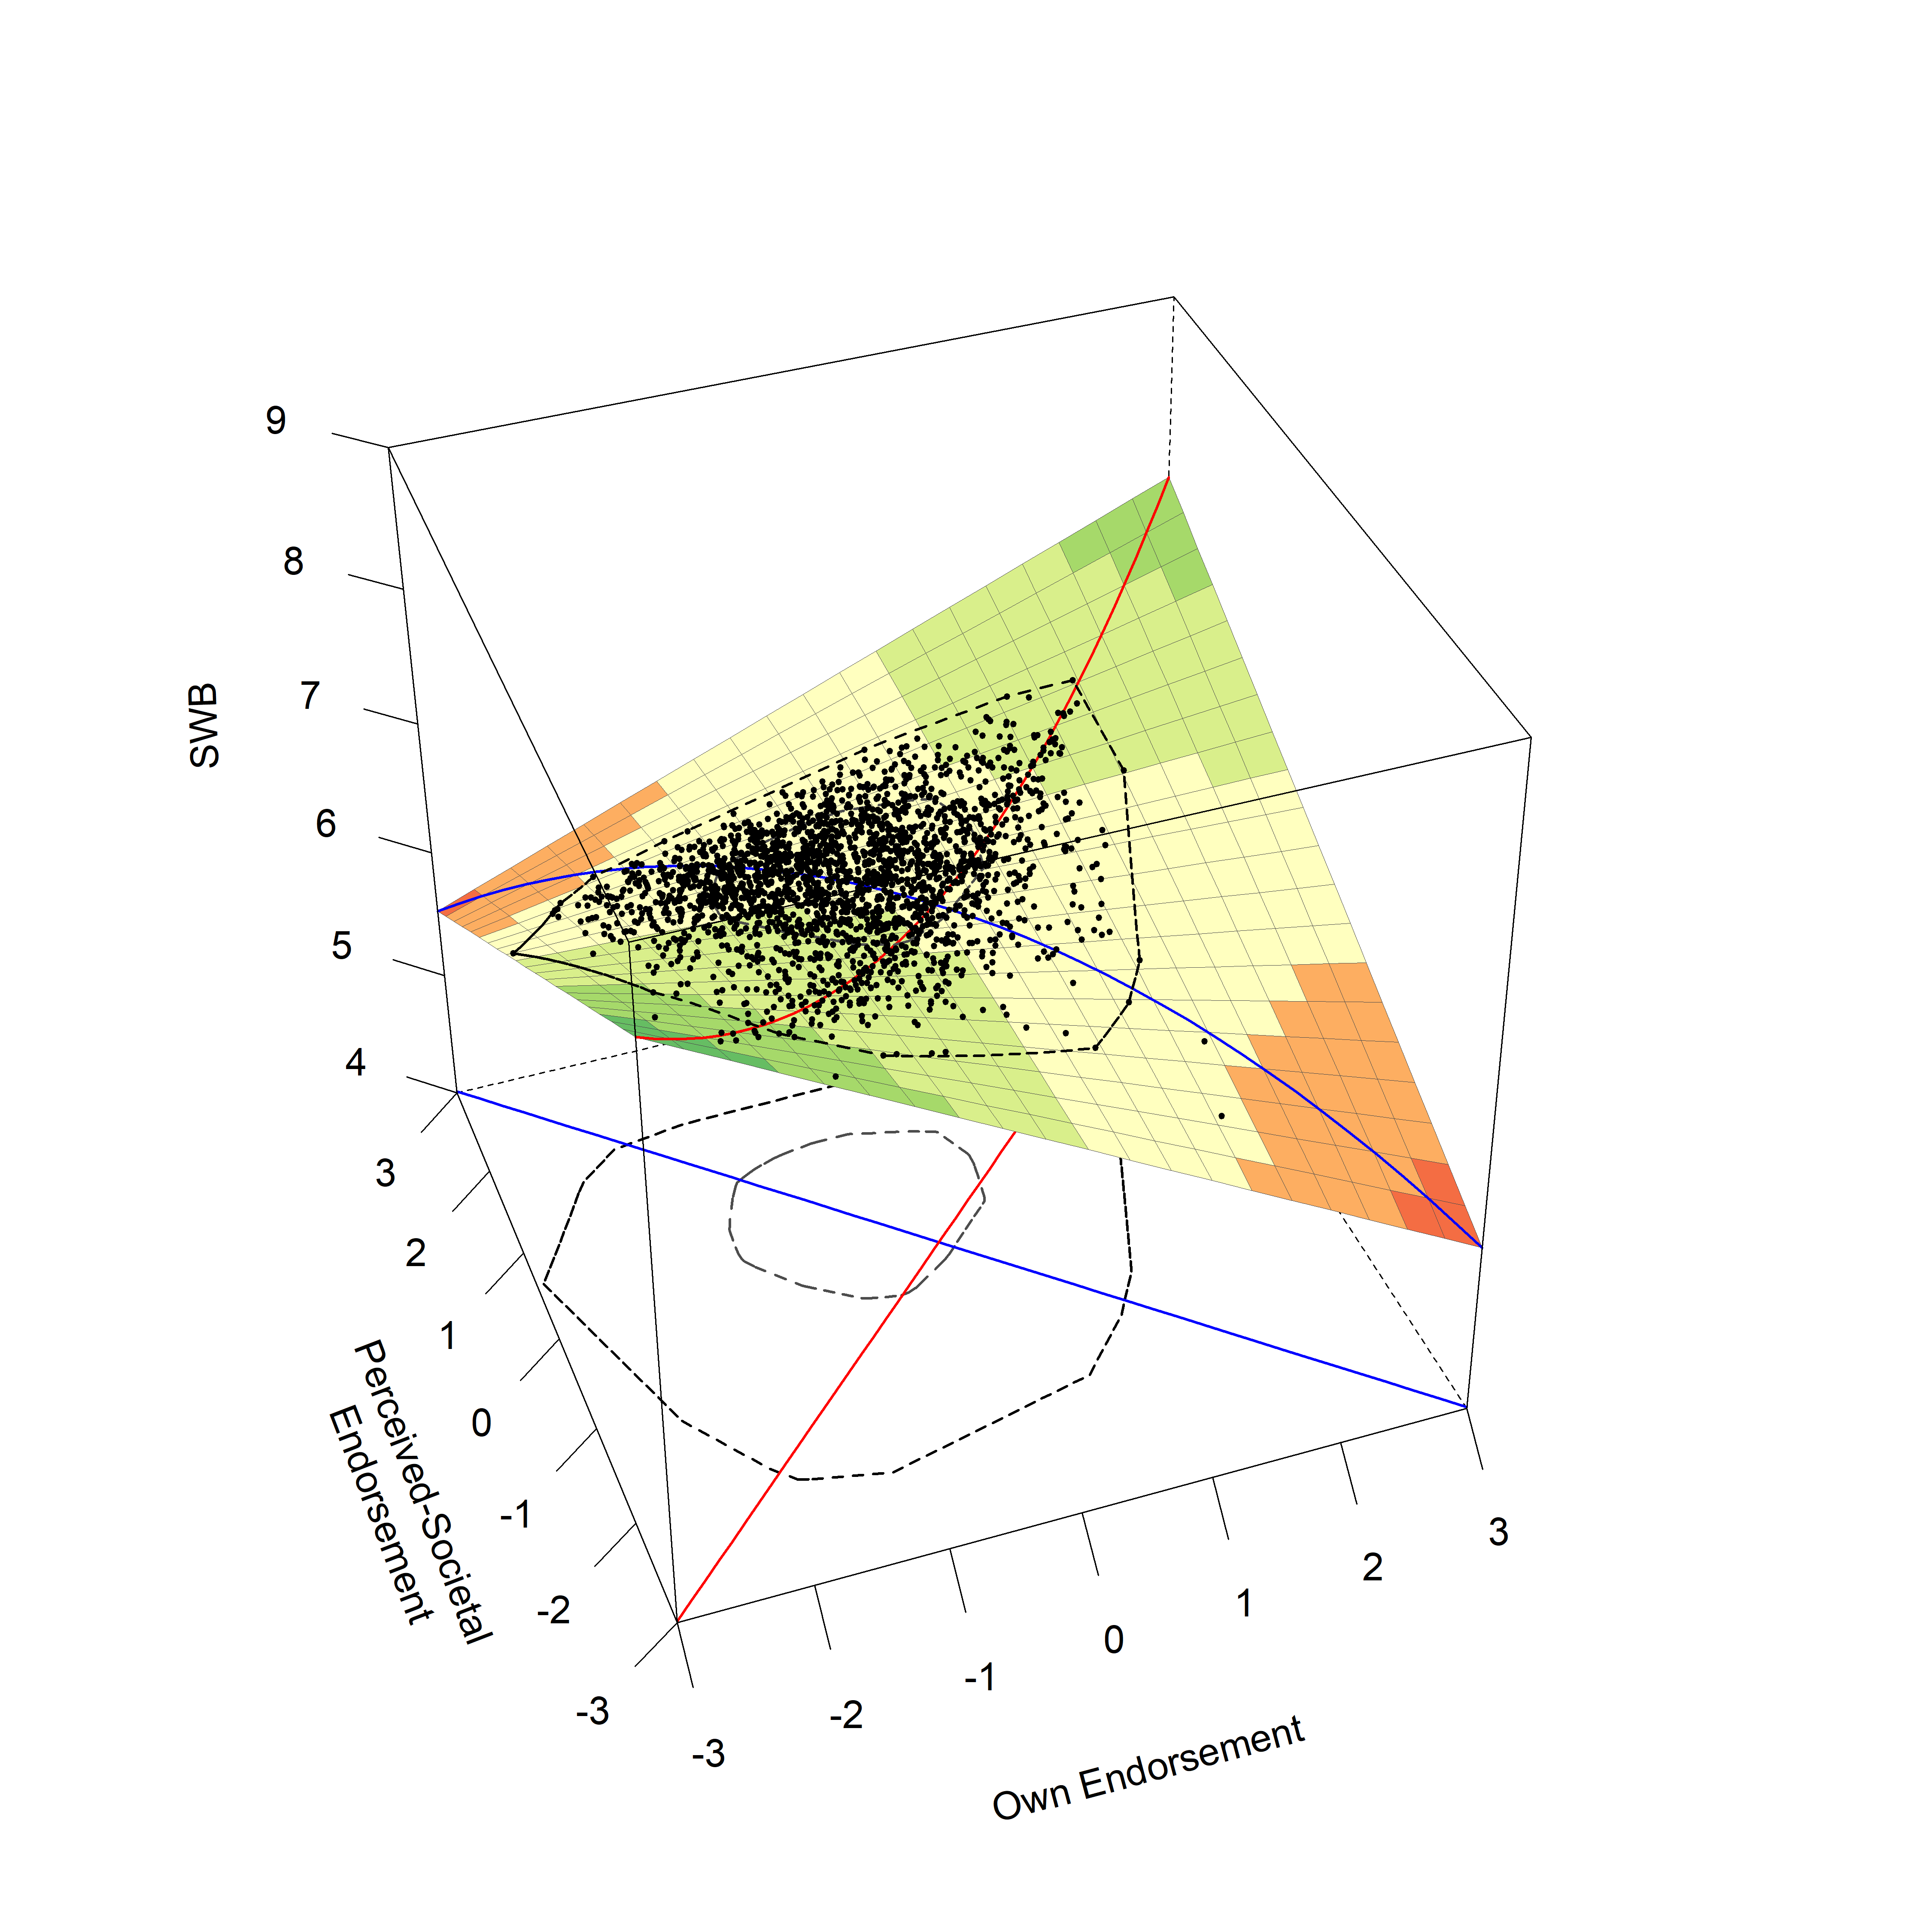

*Figure* *5.*  Shown is the response surface plot for values related to a strong self-image. Black points represent the (jittered) data points of participants at their predicted level of SWB. The red line marks the Line of Congruence, the blue line marks the Line of Incongruence. The two inner circles mark a bagplot, which describes the position of the inner 50% of points (the inner circle) and outer 50% of points (the outer circle), except outliers.

## A.2.3. Family Reputation Concerns

For family reputation concerns, we found that an **Interaction Model** was the best fitting and most parsimonious model according to our criteria based on the AIC (a difference of 3 to the second best fitting, full model).

Table 10: Model Comparison for Family Reputation Concerns

|  |  |  | ***R2*** | |
| --- | --- | --- | --- | --- |
| **Model** | ***df*** | ***AIC*** | ***Level 1*** | ***Level 2*** |
| Full Model | 10 | 43,452 | 0.029 | 0.041 |
| ***Interaction Model*** | 8 | 43,449 | 0.029 | 0.042 |
| Rising Ridge Model | 7 | 43,460 | 0.022 | 0.026 |
| Main Effects Model | 7 | 43,457 | 0.024 | 0.035 |
| Squared Difference Model | 6 | 43,487 | 0.010 | 0.022 |
| Null Model | 5 | 43,507 | 0.000 | 0.029 |
| Note. Presented are the relevant model fitting indices for the respective models compared for the Response Surface Analyses with family reputation concerns. The best fitting model according to the AIC is highlighted in italic and bold. | | | | |

Examining the model coefficients for the Interaction Model, we found no support for a congruence effect in the broad sense. The constraints introduced in an Interaction model already imply that the slope of the projected FPA is not rotated significantly from the LOC (as *p11* is constrained to 1), and thus already fulfills 1 out of the 4 conditions for a broad congruence effect. While the current Interaction model indeed showed a LOIC with an inverted u-shape (as indicated by a suggestive negative *a4* = -0.10, *p* = .001, 95% CI = [-0.16,-0.04]), the remaining two conditions were not fulfilled: the FPA of the response surface was shifted from the LOC (as indicated by a suggestive *p10* = -1.62, *p* = .039, 95% CI = [-3.15,-0.08]), and the peak of the LOIC (measured by the slope of LOIC at the point 0,0) was not aligned with the LOC either (as indicated by a suggestive positive *a3* = 0.16, *p* = .01, 95% CI = [0.04,0.28]). Finally, the model suggested a positive link between the general levels of family reputation concerns and well-being, in the form of a positive slope of the LOC at the midpoint 0,0 (as indicated by a significant positive *a1* = 0.36, *p* < .001, 95% CI = [0.27,0.46]), as well as in the shape of a u-shape of the LOC (as indicated by a significant positive *a2* = 0.10, *p* = .001, 95% CI = [0.04,0.16]). The higher country-level variables for both own honor endorsement as well as perceived-societal honor endorsement were not significant, as was the between country variance in intercepts of subjective well-being.

Table 11: Model Parameters for Family Reputation Concerns (Interaction Model).

|  |  |  |  |  |  | ***95%-CI*** | |
| --- | --- | --- | --- | --- | --- | --- | --- |
| **Label** | **Variable** | ***Estimate*** | ***SE*** | ***z*** | ***p*** | ***LL*** | ***UL*** |
| **Fixed Effects (Level 1)** | |  |  |  |  |  |  |
| b1 | Own Endorsement | 0.260 | 0.039 | 6.665 | 0.000 | 0.183 | 0.336 |
| b2 | Society Endorsement | 0.103 | 0.039 | 2.653 | 0.008 | 0.027 | 0.179 |
| b3 | Own Endorsement (Squared) | 0.000 |  |  |  |  |  |
| b4 | Own x Society Interaction | 0.097 | 0.030 | 3.252 | 0.001 | 0.038 | 0.155 |
| b5 | Society Endorsement (Squared) | 0.000 |  |  |  |  |  |
| a1 | Linear Effect LOC | 0.363 | 0.048 | 7.494 | 0.000 | 0.268 | 0.458 |
| a2 | Curvature LOC | 0.097 | 0.030 | 3.252 | 0.001 | 0.038 | 0.155 |
| a3 | Linear Effect LOIC | 0.157 | 0.061 | 2.569 | 0.010 | 0.037 | 0.276 |
| a4 | Curvature LOIC | -0.097 | 0.030 | -3.252 | 0.001 | -0.155 | -0.038 |
| p11 | Slope of Projected FPA | 1.000 |  |  |  |  |  |
| p10 | Intercept of Projected FPA | -1.618 | 0.782 | -2.069 | 0.039 | -3.150 | -0.085 |
| **Fixed Effects (Level 2)** | |  |  |  |  |  |  |
| b0 | Grand-Mean SWB | 6.163 | 0.133 | 46.266 | 0.000 | 5.902 | 6.424 |
|  | Country-Score: Own Endorsement | -0.010 | 0.397 | -0.024 | 0.981 | -0.788 | 0.769 |
|  | Country-Score: Society Endorsement | 0.212 | 0.417 | 0.509 | 0.611 | -0.605 | 1.029 |
| **Error Terms** | |  |  |  |  |  |  |
|  | Intercept Variance (Lvl-2) | 0.111 | 0.062 | 1.788 | 0.074 | -0.011 | 0.233 |
|  | Residual Variance (Lvl-1) | 2.776 | 0.083 | 33.434 | 0.000 | 2.613 | 2.939 |
| Note. Shown are parameter coefficients for the final Interaction Model for Family Reputation Concerns. In an Interaction Model, the following constraints are applied compared to the full model: b3 and b5 are set to 0. This implies that p11 is constrained to 1, and that a2 and a4 show the same estimate with opposite signs. | | | | | | | |

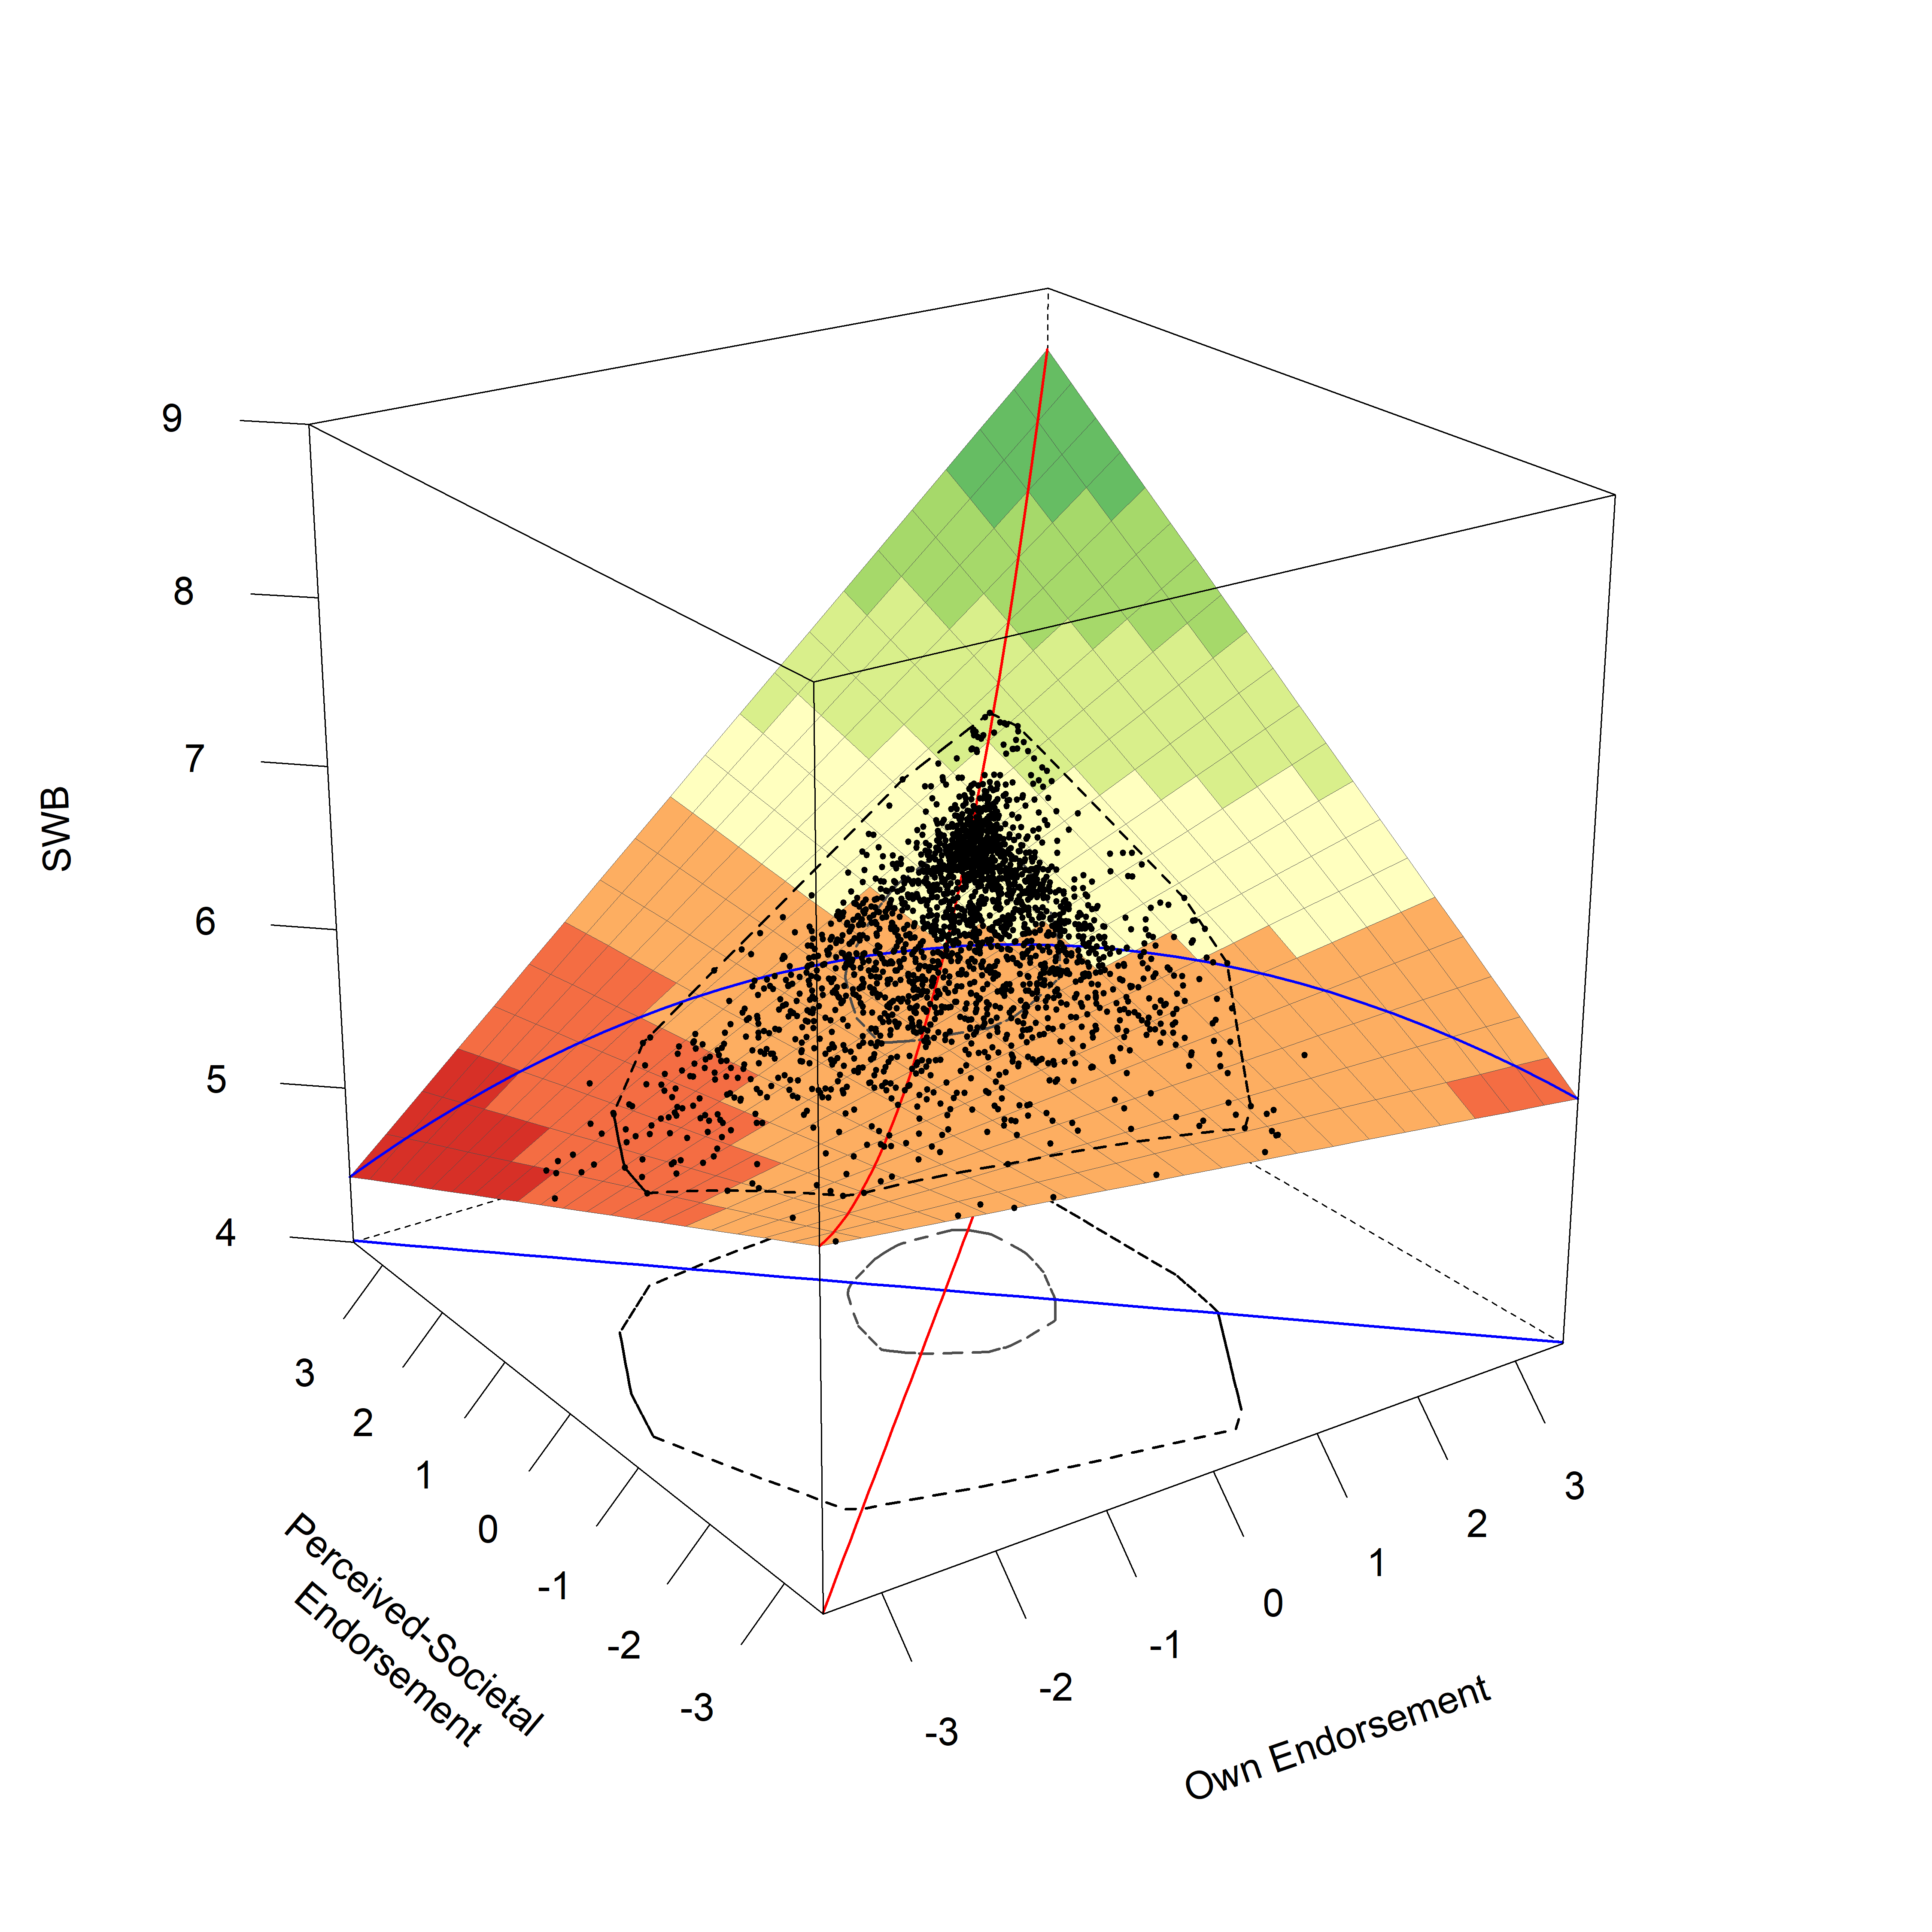

*Figure* *6.*  Shown are the resulting RSA plots for an Interaction Model of family reputation concerns. The red line marks the Line of Congruence, the blue line marks the Line of Incongruence. Black points represent jittered data points of participants. The two inner circles mark a bagplot, which describes the position of the inner 50% of points (the inner circle) and outer 50% of points (the outer circle), except outliers.

## A.2.4. Sexual Propriety Concerns

For sexual propriety concerns, we found that an **Interaction Model** was the best fitting and most parsimonious model according to our criteria based on the AIC (a difference of 3 to the second best fitting, full model).

Table 12: Model Comparison for Sexual Propriety Concerns

|  |  |  | ***R2*** | |
| --- | --- | --- | --- | --- |
| **Model** | ***df*** | ***AIC*** | ***Level 1*** | ***Level 2*** |
| Full Model | 10 | 38,359 | 0.028 | 0.008 |
| ***Interaction Model*** | 8 | 38,356 | 0.027 | 0.007 |
| Rising Ridge Model | 7 | 38,370 | 0.020 | 0.003 |
| Main Effects Model | 7 | 38,370 | 0.020 | 0.002 |
| Squared Difference Model | 6 | 38,404 | 0.004 | 0.003 |
| Null Model | 5 | 38,410 | 0.000 | 0.004 |
| Note. Presented are the relevant model fitting indices for the respective models compared for the Response Surface Analyses with sexual propriety concerns. The best fitting model according to the AIC is highlighted in italic and bold. | | | | |

Examining the model coefficients for the Interaction Model, we found no support for a congruence effect in the broad sense. The constraints introduced in an Interaction model imply that the slope of the projected FPA is not rotated significantly from the LOC (as *p11* is constrained to 1), and thus already fulfills 1 out of the 4 conditions for a broad congruence effect. While the current Interaction model indeed showed a LOIC with an inverted u-shape (as indicated by a suggestive negative *a4* = -0.08, *p* < .001, 95% CI = [-0.24,-0.08]), the remaining two conditions were not fulfilled: the FPA of the response surface was shifted from the LOC (as indicated by a suggestive *p10* = -0.93, *p* = .038, 95% CI = [-1.80,-0.05]), and the peak of the LOIC (measured by the slope of LOIC at the point 0,0) was not aligned with the LOC either (as indicated by a suggestive positive *a3* = 0.15, *p* = .019, 95% CI = [0.02,0.28]). Finally, the model also showed a positive link between general levels of sexual propriety concerns and well-being, in the form of a positive slope of the LOC at the midpoint 0,0 (as indicated by a significant positive *a1* = 0.33, *p* < .001, 95% CI = [0.23,0.43]), as well as in the shape of a u-shape of the LOC (as indicated by a significant positive *a2* = 0.16, *p* < .001, 95% CI = [0.08,0.24]). The higher country-level variables for both own honor endorsement as well as perceived-societal honor endorsement were not significant, as was the between country variance in intercepts of subjective well-being.

Table 13: Model Parameters for Sexual Propriety Concerns (Interaction Model).

|  |  |  |  |  |  | ***95%-CI*** | |
| --- | --- | --- | --- | --- | --- | --- | --- |
| **Label** | **Variable** | ***Estimate*** | ***SE*** | ***z*** | ***p*** | ***LL*** | ***UL*** |
| **Fixed Effects (Level 1)** | |  |  |  |  |  |  |
| b1 | Own Endorsement | 0.240 | 0.040 | 5.926 | 0.000 | 0.160 | 0.319 |
| b2 | Society Endorsement | 0.090 | 0.041 | 2.192 | 0.028 | 0.009 | 0.170 |
| b3 | Own Endorsement (Squared) | 0.000 |  |  |  |  |  |
| b4 | Own x Society Interaction | 0.162 | 0.040 | 4.038 | 0.000 | 0.083 | 0.240 |
| b5 | Society Endorsement (Squared) | 0.000 |  |  |  |  |  |
| a1 | Linear Effect LOC | 0.329 | 0.050 | 6.586 | 0.000 | 0.231 | 0.427 |
| a2 | Curvature LOC | 0.162 | 0.040 | 4.038 | 0.000 | 0.083 | 0.240 |
| a3 | Linear Effect LOIC | 0.150 | 0.064 | 2.340 | 0.019 | 0.024 | 0.276 |
| a4 | Curvature LOIC | -0.162 | 0.040 | -4.038 | 0.000 | -0.240 | -0.083 |
| p11 | Slope of Projected FPA | 1.000 |  |  |  |  |  |
| p10 | Intercept of Projected FPA | -0.927 | 0.446 | -2.077 | 0.038 | -1.803 | -0.052 |
| **Fixed Effects (Level 2)** | |  |  |  |  |  |  |
| b0 | Grand-Mean SWB | 6.141 | 0.152 | 40.464 | 0.000 | 5.844 | 6.439 |
|  | Country-Score: Own Endorsement | -0.076 | 0.463 | -0.165 | 0.869 | -0.985 | 0.832 |
|  | Country-Score: Society Endorsement | 0.036 | 0.611 | 0.059 | 0.953 | -1.162 | 1.234 |
| **Error Terms** | |  |  |  |  |  |  |
|  | Intercept Variance (Lvl-2) | 0.109 | 0.061 | 1.784 | 0.074 | -0.011 | 0.228 |
|  | Residual Variance (Lvl-1) | 2.782 | 0.083 | 33.397 | 0.000 | 2.619 | 2.946 |
| Note. Shown are parameter coefficients for the final Interaction Model for Sexual Propriety Concerns. In an Interaction Model, the following constraints are applied compared to the full model: b3 and b5 are set to 0. This implies that p11 is constrained to 1, and that a2 and a4 show the same estimate with opposite signs. | | | | | | | |

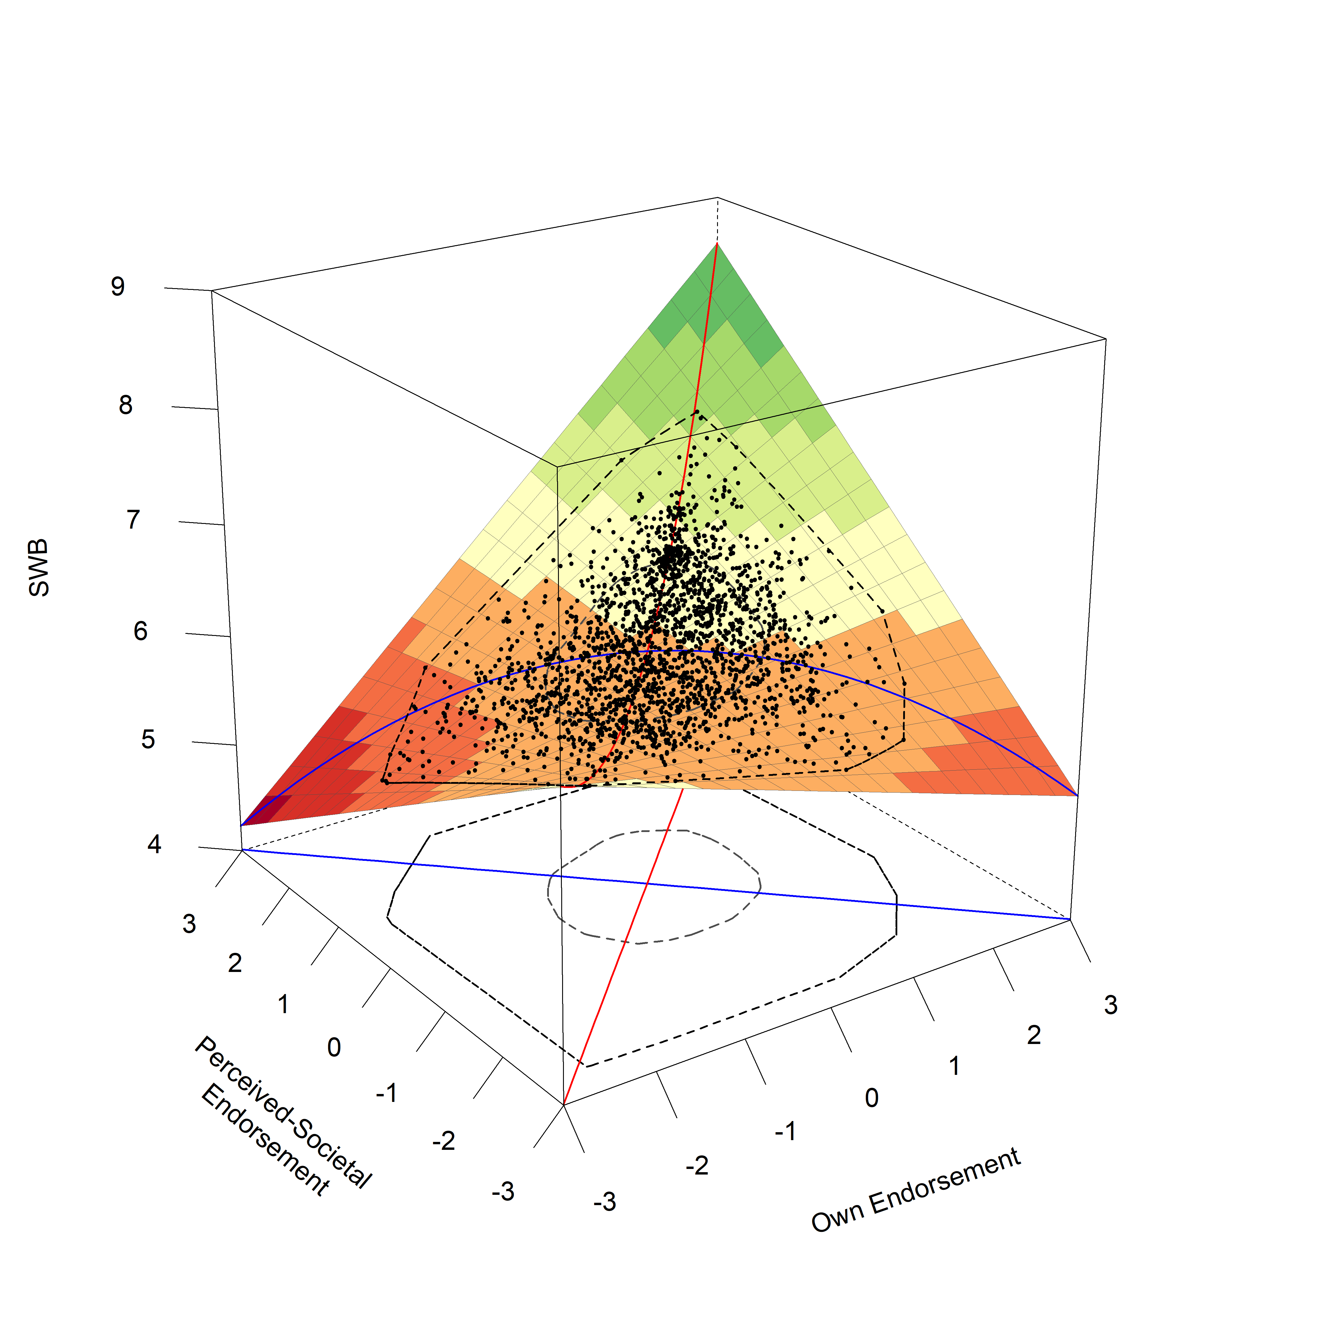

*Figure* *7.*  Shown is the resulting RSA plots for an Interaction Model of sexual propriety concerns. The red line marks the Line of Congruence, the blue line marks the Line of Incongruence. Black points represent jittered data points of participants. The two inner circles mark a bagplot, which describes the position of the inner 50% of points (the inner circle) and outer 50% of points (the outer circle), except outliers.

## A.2.5. Family Authority Concerns

For family authority concerns, we found that both a *Rising Ridge Model* as well as an **Interaction Model** both were the best fitting and most parsimonious models according to our criteria based on the AIC (a difference of 3 to the second best fitting, main effects model). We will therefore present both models in this section.

Table 14: Model Comparison for Family Authority Concerns

|  |  |  | ***R2*** | |
| --- | --- | --- | --- | --- |
| **Model** | ***df*** | ***AIC*** | ***Level 1*** | ***Level 2*** |
| Full Model | 10 | 39,600 | 0.010 | 0.093 |
| ***Interaction Model*** | 8 | 39,596 | 0.009 | 0.092 |
| ***Rising Ridge Model*** | 7 | 39,596 | 0.008 | 0.097 |
| Main Effects Model | 7 | 39,599 | 0.007 | 0.094 |
| Squared Difference Model | 6 | 39,606 | 0.003 | 0.094 |
| Null Model | 5 | 39,611 | 0.000 | 0.112 |
| Note. Presented are the relevant model fitting indices for the respective models compared for the Response Surface Analyses with family authority concerns. The best fitting models according to the AIC are highlighted in italic and bold. | | | | |

Examining the model coefficients for the Interaction Model, we found suggestive support for a broad congruence effect for own and perceived-societal family authority concerns and subjective well-being. The constraints introduced in an Interaction model already imply that the slope of the projected FPA is not rotated significantly from the LOC (as *p11* is constrained to 1), and thus already fulfills 1 out of the 4 conditions for a broad congruence effect. Examining the remaining conditions, the current model indeed showed that the FPA was not significantly shifted from the LOC (as indicated by a non-significant *p10* = -0.70, *p* = .457, 95% CI = [-2.53,1.14]). Furthermore, the LOIC showed a suggestive inverted u-shape (as indicated by a suggestive negative *a4* = -0.08, *p* = .025, 95% CI = [-0.15,-0.01]), with the peak at the midpoint 0,0 over the LOC (as indicated by a non-significant *a3* = 0.06, *p* = .39, 95% CI = [-0.07,0.18]). In addition, this broad congruence effect was complemented by a positive slope of the LOC at the midpoint 0,0 (*a1* = 0.18, *p* < .001, 95% CI = [0.09,0.28]) and a positive curvature of the LOC (a u-shape: *a2* = 0.08, *p* = .025, 95% CI = [0.01,0.15]; *a2* is constrained to be the opposite of *a4* in an interaction model), suggesting a link between general levels of the two predictors and well-being. Again, the higher country-level variables for both own honor endorsement as well as perceived-societal honor endorsement were not significant, as was the between-country variance in intercepts of subjective well-being.

Table 15: Model Parameters for Family Authority Concerns (Interaction Model).

|  |  |  |  |  |  | ***95%-CI*** | |
| --- | --- | --- | --- | --- | --- | --- | --- |
| **Label** | **Variable** | ***Estimate*** | ***SE*** | ***z*** | ***p*** | ***LL*** | ***UL*** |
| **Fixed Effects (Level 1)** | |  |  |  |  |  |  |
| b1 | Own Endorsement | 0.119 | 0.039 | 3.060 | 0.002 | 0.043 | 0.194 |
| b2 | Society Endorsement | 0.063 | 0.042 | 1.489 | 0.137 | -0.020 | 0.145 |
| b3 | Own Endorsement (Squared) | 0.000 |  |  |  |  |  |
| b4 | Own x Society Interaction | 0.080 | 0.036 | 2.243 | 0.025 | 0.010 | 0.150 |
| b5 | Society Endorsement (Squared) | 0.000 |  |  |  |  |  |
| a1 | Linear Effect LOC | 0.181 | 0.048 | 3.758 | 0.000 | 0.087 | 0.276 |
| a2 | Curvature LOC | 0.080 | 0.036 | 2.243 | 0.025 | 0.010 | 0.150 |
| a3 | Linear Effect LOIC | 0.056 | 0.065 | 0.860 | 0.390 | -0.071 | 0.183 |
| a4 | Curvature LOIC | -0.080 | 0.036 | -2.243 | 0.025 | -0.150 | -0.010 |
| p11 | Slope of Projected FPA | 1.000 |  |  |  |  |  |
| p10 | Intercept of Projected FPA | -0.697 | 0.936 | -0.744 | 0.457 | -2.531 | 1.138 |
| **Fixed Effects (Level 2)** | |  |  |  |  |  |  |
| b0 | Grand-Mean SWB | 6.205 | 0.160 | 38.672 | 0.000 | 5.891 | 6.520 |
|  | Country-Score: Own Endorsement | 0.244 | 0.366 | 0.667 | 0.505 | -0.473 | 0.961 |
|  | Country-Score: Society Endorsement | 0.037 | 0.507 | 0.073 | 0.942 | -0.956 | 1.030 |
| **Error Terms** | |  |  |  |  |  |  |
|  | Intercept Variance (Lvl-2) | 0.103 | 0.058 | 1.780 | 0.075 | -0.010 | 0.216 |
|  | Residual Variance (Lvl-1) | 2.825 | 0.085 | 33.278 | 0.000 | 2.658 | 2.991 |
| Note. Shown are parameter coefficients for the final Interaction Model for Family Authority Concerns. In an Interaction Model, the following constraints are applied compared to the full model: b3 and b5 are set to 0. This implies that p11 is constrained to 1, and that a2 and a4 show the same estimate with opposite signs. | | | | | | | |

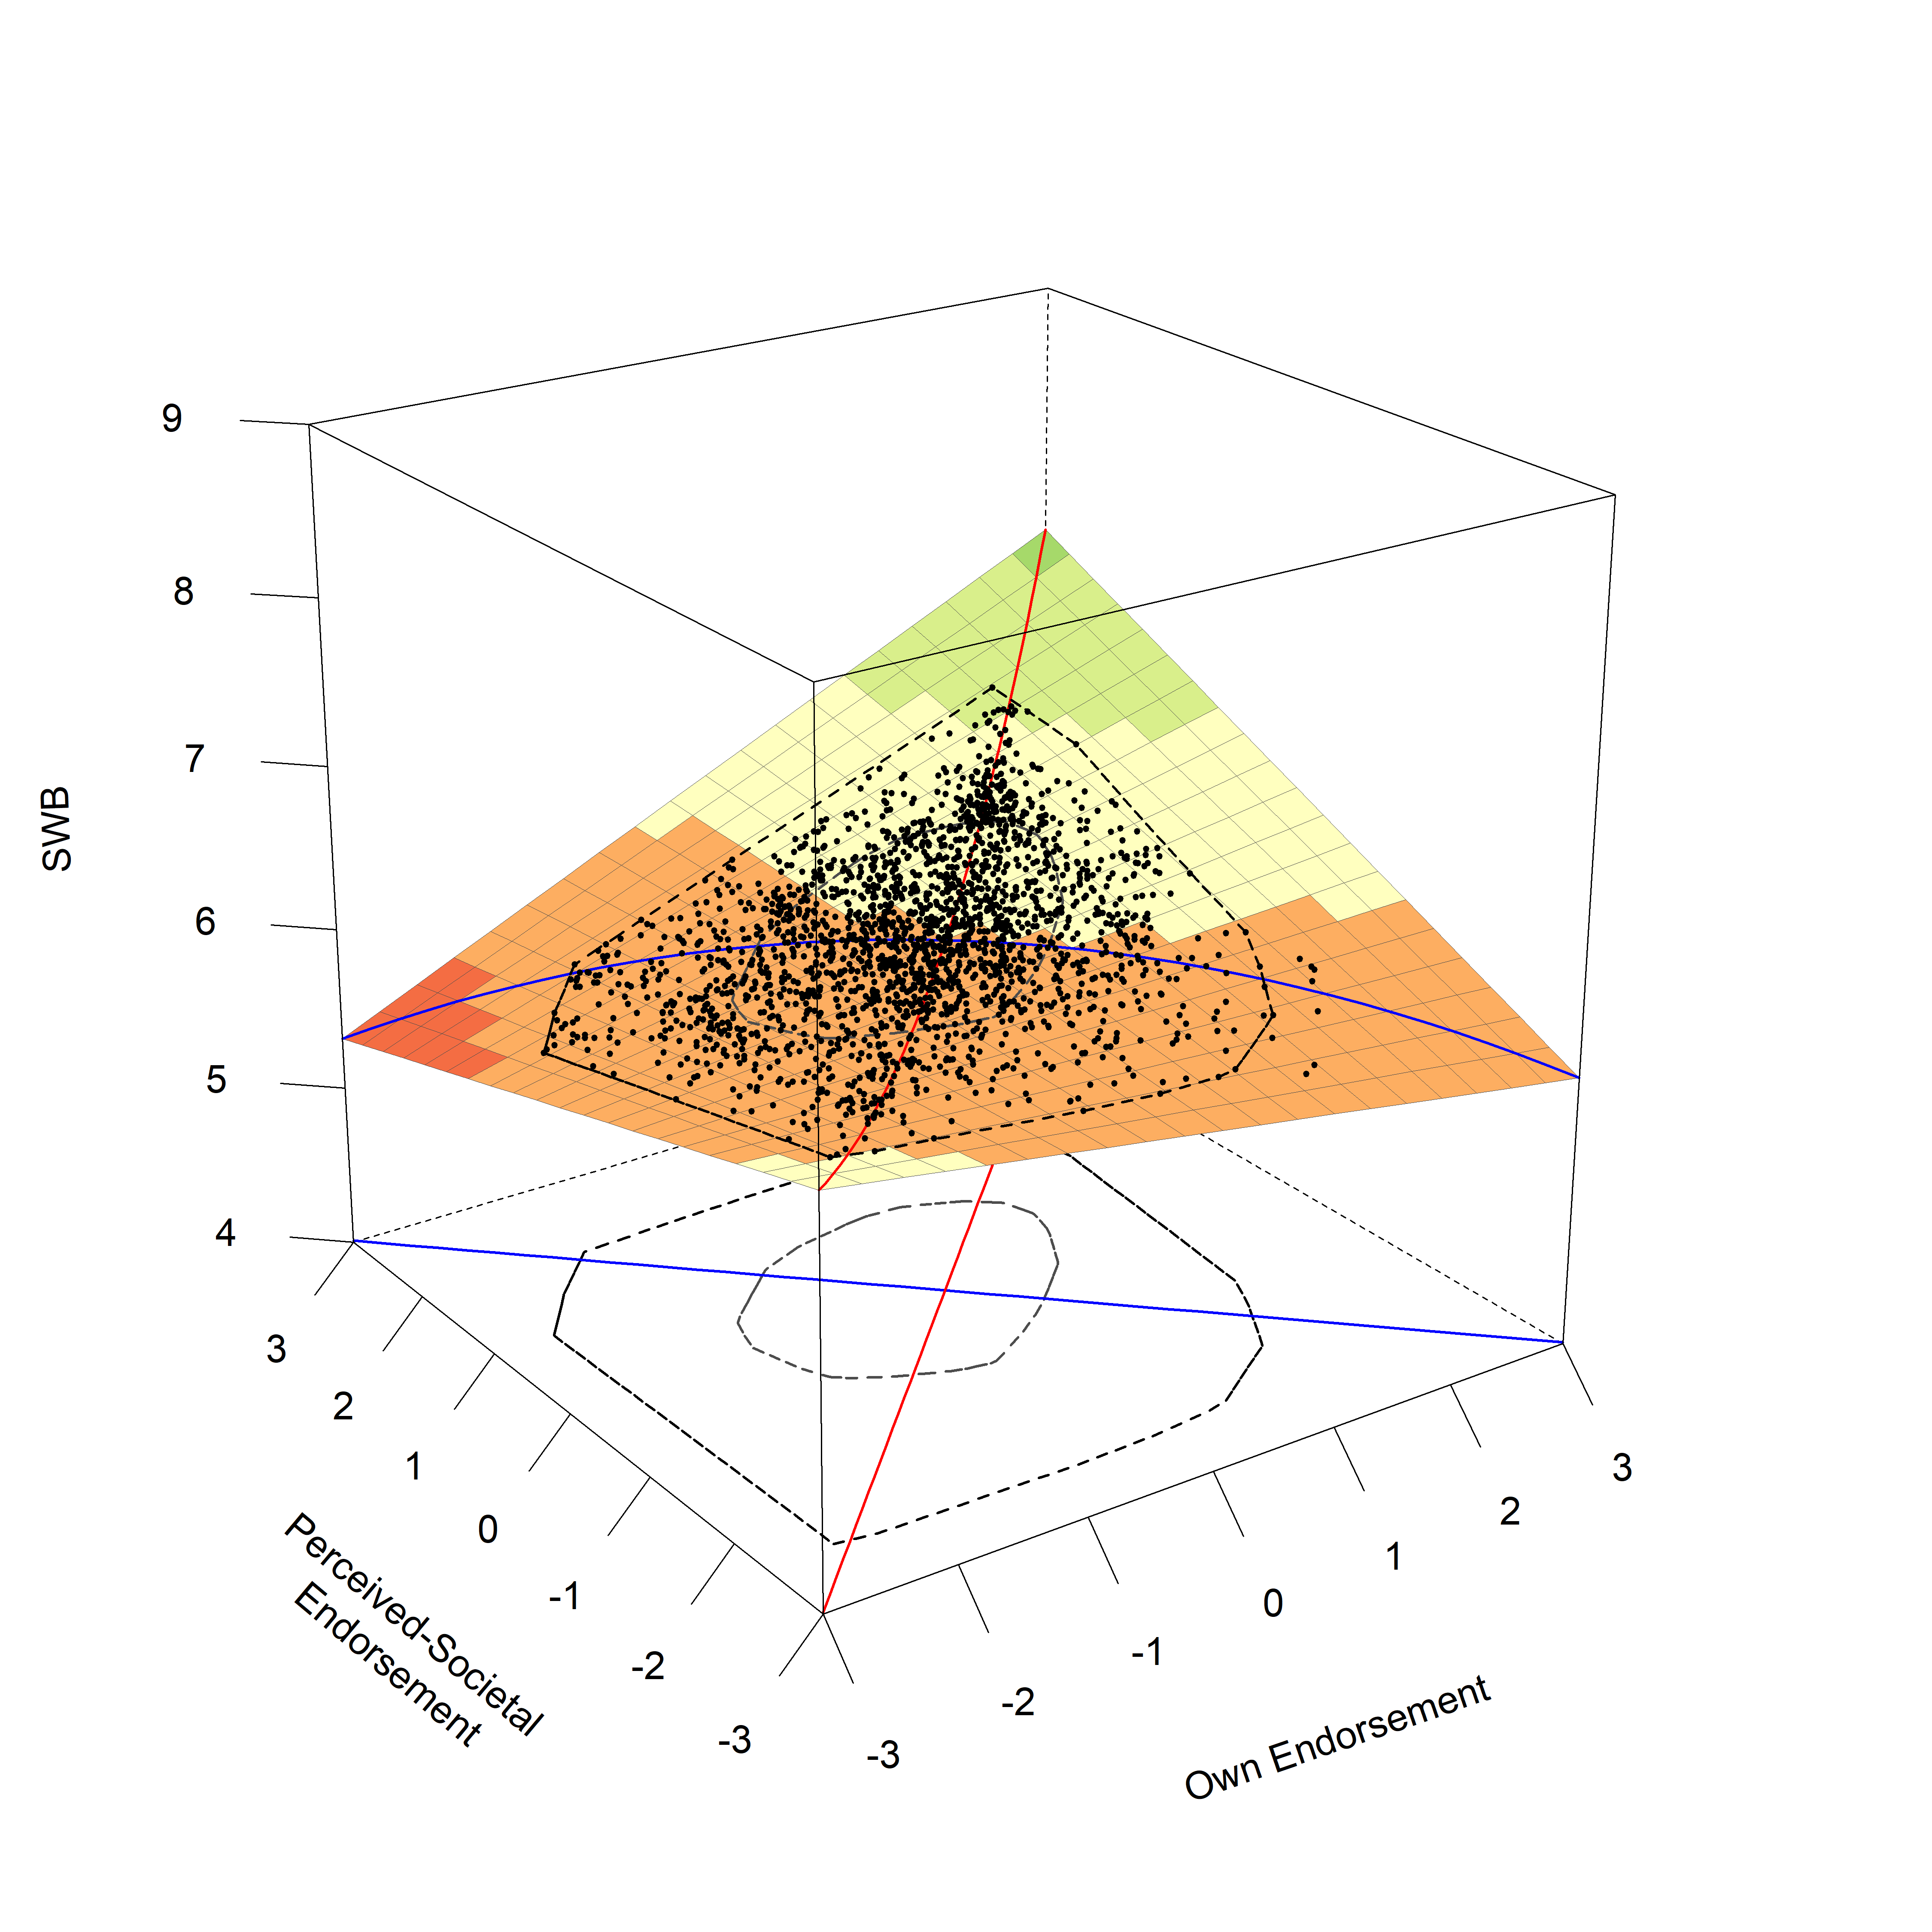

*Figure* *8.*  Shown is the resulting RSA plots for an Interaction Model of family authority concerns, the red line marks the Line of Congruence, the blue line marks the Line of Incongruence. Black points represent jittered data points of participants. The two inner circles mark a bagplot, which describes the position of the inner 50% of points (the inner circle) and outer 50% of points (the outer circle), except outliers.

Examining the model coefficients for the Rising Ridge Model, we also found support for a broad congruence effect for own and perceived-societal family reputation values and subjective well-being. The constraints introduced in a Rising Ridge model already imply that the FPA does not deviate significantly from the LOC (as *p10* is constrained to 0, and *p11* is constrained to 1), as well as that the slope of the LOIC at the midpoint 0,0 is equal to 0 (as *a3* is constrained to 0), and as such fulfills 3 out of the 4 conditions for a broad congruence effect. The current Rising Ridge model also met the final condition: an inverted u-shape of the LOIC (as indicated by a suggestive negative *a4* = -0.14, *p* = .025, 95% CI = [-0.26,-0.02]). The model also showed a positive linear effect of the LOC at the midpoint 0,0 (as indicated by a significant positive *a1* = 0.16, *p* < .001, 95% CI = [0.07,0.26]), suggesting a positive effect between general levels of honor endorsement and subjective well-being. The higher country-level variables for both own value endorsement as well as perceived-societal value endorsement were non-significant, as was the between country variance in intercepts of subjective well-being.

Table 16: Model Parameters for Family Authority Concerns (Rising Ridge Model).

|  |  |  |  |  |  | ***95%-CI*** | |
| --- | --- | --- | --- | --- | --- | --- | --- |
| **Label** | **Variable** | ***Estimate*** | ***SE*** | ***z*** | ***p*** | ***LL*** | ***UL*** |
| **Fixed Effects (Level 1)** | |  |  |  |  |  |  |
| b1 | Own Endorsement | 0.082 | 0.024 | 3.370 | 0.001 | 0.034 | 0.129 |
| b2 | Society Endorsement | 0.082 | 0.024 | 3.370 | 0.001 | 0.034 | 0.129 |
| b3 | Own Endorsement (Squared) | -0.035 | 0.016 | -2.238 | 0.025 | -0.066 | -0.004 |
| b4 | Own x Society Interaction | 0.070 | 0.031 | 2.238 | 0.025 | 0.009 | 0.132 |
| b5 | Society Endorsement (Squared) | -0.035 | 0.016 | -2.238 | 0.025 | -0.066 | -0.004 |
| a1 | Linear Effect LOC | 0.163 | 0.048 | 3.370 | 0.001 | 0.068 | 0.258 |
| a2 | Curvature LOC | 0.000 |  |  |  |  |  |
| a3 | Linear Effect LOIC | 0.000 |  |  |  |  |  |
| a4 | Curvature LOIC | -0.141 | 0.063 | -2.238 | 0.025 | -0.264 | -0.017 |
| p11 | Slope of Projected FPA | 1.000 |  |  |  |  |  |
| p10 | Intercept of Projected FPA | 0.000 |  |  |  |  |  |
| **Fixed Effects (Level 2)** | |  |  |  |  |  |  |
| b0 | Grand-Mean SWB | 6.270 | 0.161 | 38.846 | 0.000 | 5.954 | 6.586 |
|  | Country-Score: Own Endorsement | 0.260 | 0.365 | 0.714 | 0.475 | -0.454 | 0.975 |
|  | Country-Score: Society Endorsement | 0.018 | 0.506 | 0.036 | 0.972 | -0.973 | 1.009 |
| **Error Terms** | |  |  |  |  |  |  |
|  | Intercept Variance (Lvl-2) | 0.103 | 0.058 | 1.779 | 0.075 | -0.010 | 0.217 |
|  | Residual Variance (Lvl-1) | 2.827 | 0.085 | 33.277 | 0.000 | 2.661 | 2.994 |
| Note. Shown are parameter coefficients for the final Rising Ridge Model for Family Authority Concerns. In a Rising Ridge Model, the following constraints are applied compared to the full model: (a) b1 and b2 are set equal, (b) b3 and b5 are set equal, and (c) b4 is set to be -2 * b5. This implies that a2, a3, and p10 are constrained to zero, and p11 is constrained to 1. | | | | | | | |

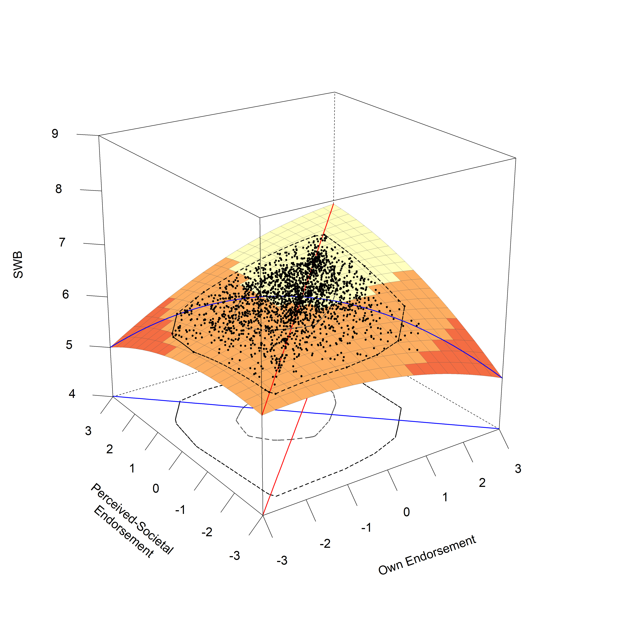

*Figure* *9.*  Shown is the resulting RSA plots for a Rising Ridge Model for family authority concerns, the red line marks the Line of Congruence, the blue line marks the Line of Incongruence. Black points represent jittered data points of participants. The two inner circles mark a bagplot, which describes the position of the inner 50% of points (the inner circle) and outer 50% of points (the outer circle), except outliers.

## A.2.6. Integrity Concerns

For integrity concerns, we found that an **Interaction Model** was the best fitting and most parsimonious model according to our criteria based on the AIC (a difference of 4 to the second best fitting, full model).

Table 17: Model Comparison for Integrity Concerns

|  |  |  | ***R2*** | |
| --- | --- | --- | --- | --- |
| **Model** | ***df*** | ***AIC*** | ***Level 1*** | ***Level 2*** |
| Full Model | 10 | 35,880 | 0.037 | 0.466 |
| ***Interaction Model*** | 8 | 35,876 | 0.037 | 0.467 |
| Rising Ridge Model | 7 | 35,888 | 0.031 | 0.459 |
| Main Effects Model | 7 | 35,891 | 0.029 | 0.462 |
| Squared Difference Model | 6 | 35,928 | 0.012 | 0.455 |
| Null Model | 5 | 35,954 | 0.000 | 0.463 |
| Note. Presented are the relevant model fitting indices for the respective models compared for the Response Surface Analyses with integrity concerns. The best fitting model according to the AIC is highlighted in italic and bold. | | | | |

Examining the model coefficients for the Interaction Model, we found no support for a congruence effect in the broad sense. The constraints introduced in an Interaction model imply that the slope of the projected FPA is not rotated significantly from the LOC (as *p11* is constrained to 1), and thus already fulfills 1 out of the 4 conditions for a broad congruence effect. While the current Interaction model showed a LOIC with an inverted u-shape (as indicated by a significant negative *a4* = -0.21, *p* < .001, 95% CI = [-0.31,-0.11]), the remaining two conditions were not met: the FPA of the response surface was shifted from the LOC (as indicated by a significant *p10* = -1.34, *p* < .001, 95% CI = [-2.01,-0.67]), and the peak of the LOIC (measured by the slope of LOIC at the point 0,0) was not aligned with the LOC (as indicated by a suggestive positive *a3* = 0.28, *p* = .006, 95% CI = [0.08,0.49]). Finally, the model also showed a positive link between general levels of sexual propriety concerns and well-being, in the form of a positive slope of the LOC at the midpoint 0,0 (as indicated by a significant positive *a1* = 0.48, *p* < .001, 95% CI = [0.37,0.60]), as well as in the shape of a u-shape of the LOC (as indicated by a significant positive *a2* = 0.21, *p* < .001, 95% CI = [0.11,0.31]). The higher country-level variables for both own honor endorsement as well as perceived-societal honor endorsement were not significant, as was the between country variance in intercepts of subjective well-being.

Table 18: Model Parameters for Integrity Concerns (Interaction Model).

|  |  |  |  |  |  | ***95%-CI*** | |
| --- | --- | --- | --- | --- | --- | --- | --- |
| **Label** | **Variable** | ***Estimate*** | ***SE*** | ***z*** | ***p*** | ***LL*** | ***UL*** |
| **Fixed Effects (Level 1)** | |  |  |  |  |  |  |
| b1 | Own Endorsement | 0.384 | 0.070 | 5.507 | 0.000 | 0.248 | 0.521 |
| b2 | Society Endorsement | 0.099 | 0.047 | 2.096 | 0.036 | 0.006 | 0.192 |
| b3 | Own Endorsement (Squared) | 0.000 |  |  |  |  |  |
| b4 | Own x Society Interaction | 0.212 | 0.052 | 4.100 | 0.000 | 0.111 | 0.314 |
| b5 | Society Endorsement (Squared) | 0.000 |  |  |  |  |  |
| a1 | Linear Effect LOC | 0.484 | 0.060 | 8.052 | 0.000 | 0.366 | 0.602 |
| a2 | Curvature LOC | 0.212 | 0.052 | 4.100 | 0.000 | 0.111 | 0.314 |
| a3 | Linear Effect LOIC | 0.285 | 0.103 | 2.764 | 0.006 | 0.083 | 0.487 |
| a4 | Curvature LOIC | -0.212 | 0.052 | -4.100 | 0.000 | -0.314 | -0.111 |
| p11 | Slope of Projected FPA | 1.000 |  |  |  |  |  |
| p10 | Intercept of Projected FPA | -1.343 | 0.342 | -3.924 | 0.000 | -2.013 | -0.672 |
| **Fixed Effects (Level 2)** | |  |  |  |  |  |  |
| b0 | Grand-Mean SWB | 5.530 | 0.688 | 8.044 | 0.000 | 4.183 | 6.878 |
|  | Country-Score: Own Endorsement | 1.493 | 1.006 | 1.484 | 0.138 | -0.478 | 3.465 |
|  | Country-Score: Society Endorsement | 0.448 | 0.511 | 0.877 | 0.381 | -0.554 | 1.450 |
| **Error Terms** | |  |  |  |  |  |  |
|  | Intercept Variance (Lvl-2) | 0.063 | 0.037 | 1.696 | 0.090 | -0.010 | 0.135 |
|  | Residual Variance (Lvl-1) | 2.756 | 0.082 | 33.443 | 0.000 | 2.595 | 2.918 |
| Note. Shown are parameter coefficients for the final Interaction Model for Integrity Concerns. In an Interaction Model, the following constraints are applied compared to the full model: b3 and b5 are set to 0. This implies that p11 is constrained to 1, and that a2 and a4 show the same estimate with opposite signs. | | | | | | | |

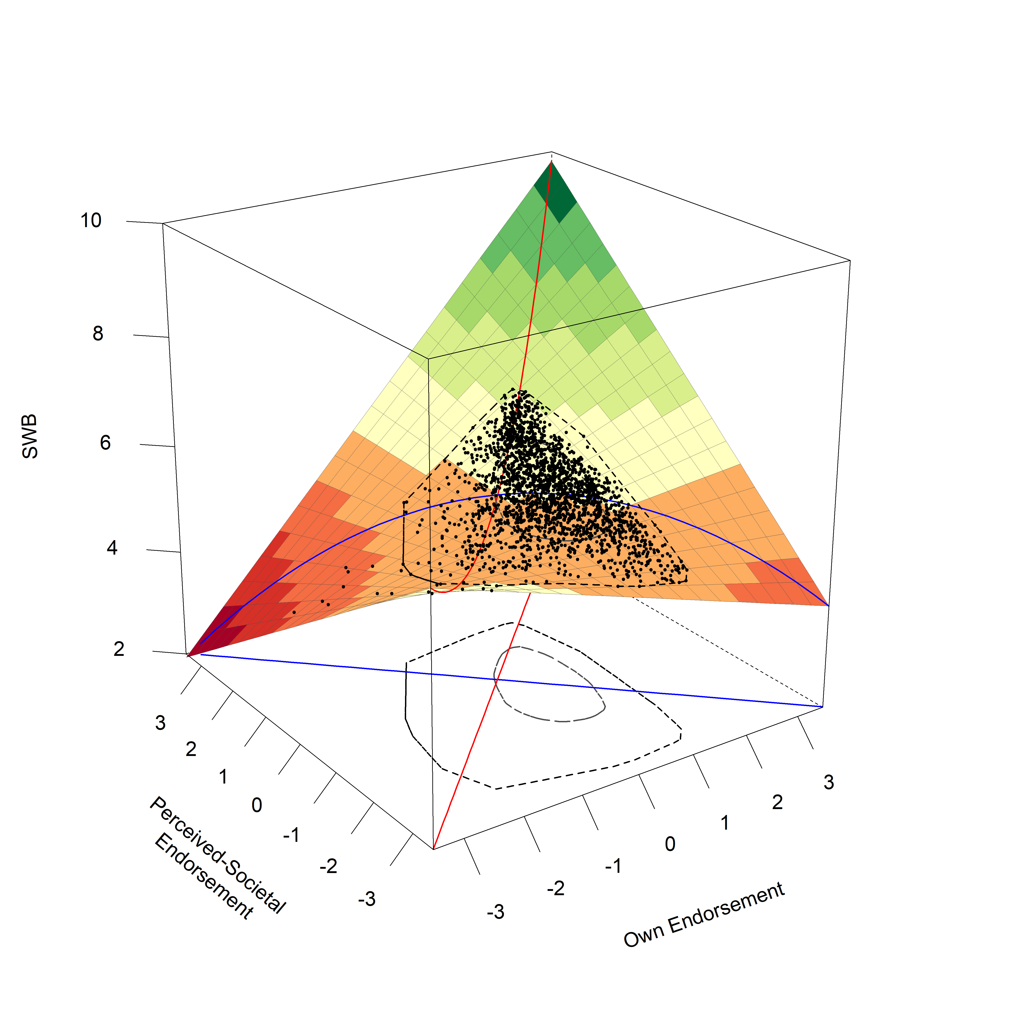

*Figure* *10.*  Shown is the resulting RSA plots for an Interaction Model for integrity concerns, the red line marks the Line of Congruence, the blue line marks the Line of Incongruence. Black points represent jittered data points of participants. The two inner circles mark a bagplot, which describes the position of the inner 50% of points (the inner circle) and outer 50% of points (the outer circle), except outliers.

## A.2. Overview over Profile Fit Analysis

We used the *Intraclass Correlation with Double Entry* (ICC-DE; McCrae, 2008) as the statistical index of profile fit. The ICC-DE is sensitive to differences in profile levels and profile shape and has been shown to perform generally better than other indices of fit (e.g., simple Pearson Correlations; McCrae, 2008). In this method, the scores of the two variables for which fit is being determined are entered twice, but in reversed order across rows, where all entries in the first column are appended to the second column in new rows, and all entries that are in the second column are appended to the second column in new rows, effectively doubling the dataset. The ICC-DE is then calculated as the Pearson correlation between the two columns. In our data, this means that a participant’s own endorsement (column 1) would be appended to the group average scores across the same items (column 2), and vice versa. Please consult McCrae (2008) for more information.